UNIVERSITY OF CAPE COAST
COLLEGE OF AGRICULTURAL AND NATURAL SCIENCES
SCHOOL OF PHYSICAL SCIENCES
DEPARTMENT OF COMPUTER SCIENCE AND INFORMATION TECHNOLOGY

DESIGN AND IMPLEMENTATION OF A SECURE MOBILE MARKETPLACE APPLICATION FOR CAMPUS BUSINESSES AND STUDENTS AT UCC – MANDUU

GROUP 3 (ANIM BERNARD OBENG, ANTHOINETTE KUNTUO ASARE, GAZALI ALADAGO MUMUNI, TORIKUUBU HUDA)

2025
UNIVERSITY OF CAPE COAST
DESIGN AND IMPLEMENTATION OF A SECURE MOBILE MARKETPLACE APPLICATION FOR CAMPUS BUSINESSES AND STUDENTS AT UCC – MANDUU

BY
GROUP 3 (ANIM BERNARD OBENG, ANTHOINETTE KUNTUO ASARE, GAZALI ALADAGO MUMUNI, TORIKUUBU HUDA)

Thesis submitted to the Department of Computer Science and Information Technology of the School of Physical
Sciences, College of Agriculture and Natural Sciences, University of Cape
Coast, in partial fulfilment of the requirements for the award of Bachelor of
Science Degree in Physics.

AUGUST, 2025

DECLARATION
Candidate’s Declaration
I hereby declare that this project work is the result of my own original research and that no part of this has been presented for another degree in this university or elsewhere.

Candidate's Signature ……………………… Date: ………………………
Index Number: PS/CSC/21/0011
Name: Anim Bernard Obeng
Candidate's Signature ……………………… Date: ………………………
Index Number: PS/CSC/21/0012
Name: Anthoinette Kuntuo Asare
Candidate's Signature ……………………… Date: ………………………
Index Number:
Name: Gazali Aladago Mumni
Candidate's Signature ……………………… Date: ………………………
Index Number: PS/CSC/21/0033
Name: Huda Torikuubu
Supervisors’ Declaration
I hereby declare that the preparation and presentation of this project work was supervised in accordance with the guidelines on supervision of project laid down by the University of Cape Coast.

Supervisor's Signature: …………………… Date: ………………………………
Name: Dr. Regina Turkson

ABSTRACT
Campus-based commerce at the University of Cape Coast (UCC) is largely informal, relying on word of mouth, posters, and scattered social media platforms. These systems create inefficiencies, long queues, limited visibility for vendors, and mistrust among students. This study addresses these challenges through the design and evaluation of MANDUU, a prototype mobile marketplace tailored for UCC that integrates vendor verification, geo-fenced service discovery, and secure digital payments.
Using the Design Science Research (DSR) methodology, the study employed a mixed-methods approach. Surveys and interviews with students and vendors highlighted high demand for services such as printing, stationery, laundry, device repair, and grooming, alongside persistent challenges of trust, accessibility, and inconsistent quality. Vendors showed strong interest in a campus-specific platform but emphasized the need for training and marketing support.
MANDUU responds to these gaps by offering verified vendor profiles, location-based listings, e-printing, mobile money and card payments, and a transparent review system. The prototype demonstrates how digital platforms can enhance trust, efficiency, and entrepreneurial opportunity within campus economies. The findings suggest MANDUU can significantly improve student experiences at UCC while providing a scalable model for other Ghanaian universities.
Keywords: MANDUU, campus commerce, University of Cape Coast, digital marketplace, vendor verification, mobile payments, Design Science Research.

ACKNOWLEDGEMENT
The successful completion of this project has been possible through the collective guidance, support, and contributions of many individuals and institutions. We wish to take this opportunity to extend our sincere appreciation to all who played a role in this academic journey.
First, we are deeply grateful to Almighty God for the strength, wisdom, and perseverance to undertake this research from the proposal stage to the final documentation.
We wish to express our heartfelt gratitude to our supervisor, Dr. Regina Turkson whose invaluable guidance, constructive feedback, and encouragement provided direction from the early stages of developing the proposal through to the completion of all five chapters and the development of the app.
Special thanks go to the faculty and staff of the Department of Computer Science and Information Technology, whose commitment to academic excellence provided the environment and resources necessary to carry out this project. We also appreciate the contributions of our peers and colleagues who offered feedback, shared resources, and provided moral support throughout the process.
We are equally indebted to the vendors and respondents who willingly participated in the survey and interviews, thereby providing the data that formed the basis of this research. Their openness and cooperation were critical in shaping the results and discussions.
Finally, we acknowledge the support of our families and friends. Their encouragement, understanding, and unwavering belief in us gave us the motivation to persevere and complete this dissertation successfully.
To all who contributed in one way or another to the success of this work from the conceptualization of the proposal through the literature review, methodology, data analysis, and conclusion, we remain sincerely grateful.

DEDICATION
We dedicate this work to our supervisor, whose guidance and supervision made this research possible, and to all members of the project team for their commitment and collaboration from the proposal stage through to the completion of this dissertation. We also dedicate this study to the academic community and future researchers who seek to explore innovative solutions that address real challenges within our society.

TABLE OF CONTENTS
DECLARATION iii
ABSTRACT iv
ACKNOWLEDGEMENT v
DEDICATION vii
LIST OF FIGURES xi
CHAPTER ONE: INTRODUCTION 1
Background Of Study 1
Statement of the Problem 5
Purpose of the Study 8
Objectives of the Study 13
Research Questions 17
Significance of the Study 20
Limitations of Study 24
Delimitations of the Study 29
CHAPTER 2 – LITERATURE REVIEW 34
Introduction 34
Digital Marketplaces in Campus Contexts 35
Mobile Commerce and Payment Adoption in Ghana 39
Trust, Vendor Verification and Informal Economies 43
Location-Based Services and Geo-Fencing for Campuses 47
Remote E-printing Integration 50
Usability, Technology Acceptance (TAM) and Evaluation Approaches 54
Critical Comparison with Related Work 57
Synthesis and Research Gaps 61
Conclusion 65
CHAPTER THREE: METHODOLOGY 68
Research Design 68
Research Approach 73
Study Area and Population 79
Data Collection Methods 84
Data Collection Instruments 86
Data Analysis Plan 90
Ethical Considerations 92
CHAPTER FOUR: DATA REPRESENTATION AND ANALYSIS 95
INTRODUCTION 95
Demographic Characteristics of Respondents 96
Service Use Patterns – Students 99
Vendor Challenges and Practice 103
Trust Safety and Discovery Analysis 110
Prototype Demonstration 116
System Testing and Evaluation 126
CHAPTER FIVE: DISCUSSION, CONCLUSION AND RECOMMENDATIONS 129
Introduction 129
Discussion of Findings 130
Conclusion 134
Recommendations and Suggestions for Future Research 135
REFERENCES 138

LIST OF FIGURES
Figure 1.1: Model-View-ViewModel (MVVM) Architecture 10
Figure 1.2: System Architecture of the MANDUU App 11
Figure 1.3: .NET MAUI Framework Architecture for Cross-Platform App Development 32
Figure 3.1: Adapted DSR methodology diagram 71
Figure 3.2 Visual representation of research approach 77
Figure 3.3 Visual representation of research approach 78
Figure 4.1: Pie chart of males and females who partook in the survey (from student CSV) 97
Figure 4.2: Bar chart of age range of respondents (from student CSV) 97
Figure 4.3: Pie chart of respondents’ levels of study (from student CSV) 97
Figure 4.4: Pie chart of respondents’ residence status (from student CSV) 98
Figure 4.5: Pie chart of services offered by vendor respondents (from vendor CSV) 98
Figure 4.6: Bar chart of service categories used by students (from student CSV). 100
Figure 4.7: Frequency of service usage (pie chart or bar chart from student CSV). 101
Figure 4.8: Proportion of students who act as vendors or plan to start (bar chart). 101
Figure 4.9: Percentage of students reporting challenges with campus vendors (pie chart and bar chart from student CSV). 103
Figure 4.10: Distribution of vendor service categories (bar chart from vendor CSV). 104
Figure 4.12: Reported challenges by vendors (percentage breakdown). 106
Figure 4.13: Vendor willingness to join MANDUU (pie chart). 107
Figure 4.14: Vendor support requirements (bar chart). 108
Figure 4.15: Importance of trust and verification in vendor selection (student ratings). 111
Figure 4.16: Current service discovery methods among students (pie chart and bar chart). 112
Figure 4.17: Types of challenges faced with campus vendors (percentage breakdown). 113
Figure 4.18: Ranked importance of vendor selection factors (student ratings on proximity and price). 114
Figure 4.19: Ranked importance of vendor selection factors (student ratings on quality of services and recommendation by friends). 114
Figure 4.20: Ranked importance of vendor selection factors (student ratings on vendor verification and visibility). 114
Figure 4.21: MANDUU trust and discovery framework (illustrative diagram – to be designed). 116
Figure 4.22: MANDUU Home Screen & Service Categories 117
Figure 4.23: Vendor Profile with Verification Badge 118
Figure 4.24: E-Printing shop selection screen 119
Figure 4.25: Vendor dashboard screens displaying order requests, sales history and customer views and engagement. 123
Figure 4.26: Purchases interface showing active orders and order history. 124
Figure 4.27: Payment Checkout Screen 126

CHAPTER ONE: INTRODUCTION

Background Of Study
The rapid evolution of mobile and internet technologies has transformed the way individuals interact with goods and services globally. According to GSMA’s 2023 Mobile Economy Report, over 5.4 billion people globally subscribed to mobile services, and mobile internet penetration reached nearly 60% of the global population. In sub-Saharan Africa, mobile adoption continues to grow significantly, with smartphone penetration projected to rise from 49% in 2022 to 61% by 2025 (GSMA, 2023). This increased access to mobile devices and internet connectivity is driving the expansion of mobile-based digital services, including mobile commerce (m-commerce), especially in regions where traditional brick-and-mortar infrastructure is limited.
In Ghana, mobile phone usage is highly prevalent. As of 2023, Ghana had over 43 million mobile connections, which is more than 130% of its population (DataReportal, 2023). Similarly, mobile money platforms such as MTN Mobile Money and Vodafone Cash have become the preferred method of financial transactions for many Ghanaians. The Bank of Ghana (2023) reported that the total value of mobile money transactions reached over GHS 1 trillion in 2022, underscoring the population’s reliance on digital financial services. With this rise in digital interaction, there is increasing potential to localize and contextualize mobile-based solutions to meet the needs of specific environments such as university campuses.

The Campus Environment in Ghana.
University campuses in Ghana, such as the University of Cape Coast (UCC), represent vibrant micro-economies composed of thousands of students, faculty, and staff. These communities rely heavily on informal vendors for daily goods and services including printing, laundry, hairdressing, and academic support. Despite their essential role, these vendors often operate in unstructured ways, without formal digital presence or regulatory oversight. According to Owusu-Mintah & Adjei-Boadi (2021), campus vendors typically lack access to business support services, including digital platforms, resulting in fragmented access to student markets.
The informal nature of these businesses presents several challenges:
Students often rely on word-of-mouth to discover services, which is inefficient and limited in reach.
There is no standardized system for verifying vendor authenticity, leading to potential scams or subpar service.
Service congestion, especially at printing centres, leads to long queues and wasted academic time.
The absence of digital channels for service discovery and payment inhibits transparency, security, and convenience.
Moreover, although students are digitally literate and generally possess smartphones, few mobile applications cater specifically to campus-based service needs. Popular platforms like Jiji, Tonaton, and Hubtel provide broad classified or e-commerce services, but they are not localized or optimized for campus use. These platforms do not include geo-restricted listings, academic service features (e.g., remote document printing), or vendor vetting mechanisms. As such, they fail to address the specific transactional and trust-related needs of university environments.

Mobile Commerce and Digital Trust
Trust plays a critical role in mobile commerce adoption. Gefen et al. (2003) argue that users are more likely to adopt digital platforms when they trust both the service provider and the technology. In Ghana, where cash-based informal trade is the norm, transitioning to mobile payments requires a significant level of assurance in both vendor credibility and payment security. Studies by Asare et al. (2020) and Tetteh & Amankwah (2019) found that perceived trust and ease of use are strong predictors of m-commerce usage among Ghanaian youth. Therefore, successful digital marketplaces must embed trust-building mechanisms such as vendor verification, secure payment integration, and user review systems to encourage adoption.

Location-Based Services and Smart Campus Innovation
Globally, universities are leveraging smart campus systems to digitize service access, security, and student engagement. One aspect of this transformation is the use of location-based services (LBS) to help students navigate campus life. According to Zhao et al. (2020), location-aware campus apps improve convenience and enhance service efficiency by matching student needs to nearby resources. However, in Ghana, LBS integration into campus-specific mobile apps remains underexplored.
A mobile marketplace embedded with LBS would enable students to easily discover nearby vendors and services, particularly during high-demand periods such as exam weeks. Such functionality aligns with research by Nyarko and Osei (2021), who emphasized the need for “context-aware” mobile solutions to support the logistical and academic demands of Ghanaian tertiary students.

Need for an Integrated Campus Marketplace
Given the increasing digitization of Ghana’s financial and communication infrastructure, university campuses present a unique opportunity for localized innovation. A mobile application that:
- connects students with verified campus vendors,
- integrates secure mobile money payments,
- uses GPS for real-time vendor discovery, and
- allows remote document printing and pickup scheduling
…would not only enhance campus service delivery but also promote inclusive digital participation for informal vendors. Such a solution would support UCC’s strategic goals of digital transformation, improve student welfare, and encourage campus entrepreneurship.
The proposed project, MANDUU, addresses this need by building a secure, location-based mobile marketplace tailored to the University of Cape Coast. It is grounded in modern development frameworks (such as .NET MAUI), leverages Ghana’s robust mobile payment systems, and incorporates user-centred design to ensure adoption and usability.

Statement of the Problem
University campuses in Ghana, such as the University of Cape Coast (UCC), are dynamic socio-economic microcosms where students, faculty, staff, and vendors interact daily within a self-contained ecosystem. While these interactions generate significant demand for services such as food delivery, document printing, hairstyling, tutoring, and room rentals, the infrastructure supporting these services, especially in terms of discovery, authentication, and payment, remains underdeveloped and informal.
Despite a digital landscape that is rapidly maturing across Ghana, UCC lacks a centralized, trusted, and digitally managed campus marketplace. Students often rely on informal means such as word-of-mouth, social media groups, WhatsApp referrals, and flyers to discover local service providers. These fragmented channels not only limit accessibility and reach but also pose serious challenges to service quality, security, and operational efficiency. The absence of a formal platform to connect students with verified vendors results in persistent transactional problems, including vendor unreliability, service duplication, exploitation, and misinformation (Owusu-Mintah & Adjei-Boadi, 2021). Fragmented Access to Services
One of the primary challenges is the lack of a centralised system for accessing campus-based goods and services. Students often discover vendors through word-of-mouth, handwritten posters, or personal referrals, which is inefficient and unreliable. This often results in students missing out on better, closer, or more affordable services simply because they lack visibility. A survey by Owusu-Mintah & Adjei-Boadi (2021) found that 68% of UCC students had difficulty locating service providers for basic needs like printing, food delivery, or laundry, especially during peak academic periods.

Trust Deficiency in Informal Transactions
A core issue is the lack of trust infrastructure within the campus commerce environment. Trust, according to McKnight et al. (2002), is a fundamental prerequisite for the successful adoption of digital platforms, especially those involving financial transactions. Informal vendors often operate without business registration, identity verification, or traceability, making it difficult for students to assess legitimacy. The risk of fraud, impersonation, and overpricing is high—factors that discourage digital interaction and promote reliance on cash and in-person transactions.
In a study by Tetteh & Amankwah (2019), Ghanaian youth cited concerns about digital fraud, lack of authentication, and misinformation as primary barriers to e-commerce adoption. This mirrors campus environments, where students have reported incidents of being scammed by unverified vendors or receiving poor-quality goods/services from contacts found through social media or word-of-mouth.

Inefficient Service Discovery and Fragmented Communication
Campus vendors often operate in obscurity, with limited channels to promote their services outside of manually distributed leaflets or informal WhatsApp groups. Students must rely on social capital or peer referrals to locate essential services. This lack of structured service visibility results in:
Missed opportunities for both students and vendors.
Duplication of services in a few locations (e.g., multiple print shops in one area and none in others).
Congestion at popular service points while others remain underutilized.
The lack of a digital directory or proximity-based service discovery tool creates a misalignment between service demand and supply across campus zones. Students new to campus (especially first-years) are disproportionately affected due to unfamiliarity with locations and trusted vendors.

Inadequacy of Existing Digital Platforms
While e-commerce platforms such as Jiji, Tonaton, and Hubtel are available in Ghana, they are not optimized for the localized, community-centric, and academic nature of university campuses. Their limitations include:
- No vendor verification based on university affiliation.
- No support for academic services like course materials, remote printing, or group tutoring.
- Lack of geofencing or campus-specific filtering, which makes service discovery irrelevant for students.
These platforms cater to national audiences, lack campus-specific use cases, and fail to meet the unique needs of a student community that functions within a distinct physical and academic ecosystem.

Institutional Blind Spots and Missed Data Opportunities
From an institutional standpoint, the absence of a structured campus commerce system also limits the university's capacity to:
- Monitor service availability or quality.
- Support campus-based entrepreneurship through structured visibility.
- Gather data on economic activity that could inform planning, welfare, or policy.
Universities that lack such infrastructure miss opportunities to lead digital transformation, integrate student-driven innovation, or strengthen campus economies through digital support frameworks.
In a digital-first world, universities must modernize internal service delivery and support structures—not only for academic excellence but also for socio-economic inclusivity and entrepreneurship.

Purpose of the Study
The purpose of this study is to design, develop, and evaluate a secure, location-based mobile marketplace application, MANDUU, that connects verified vendors with students at the University of Cape Coast (UCC). The application seeks to bridge the digital gap between students and campus-based service providers by providing a centralized, trusted, and mobile-friendly platform that supports secure payments, proximity-based service discovery, and academic-related transactions such as remote printing. The study addresses the increasing need for digital transformation in the informal economic activities that dominate university campuses in Ghana.
As highlighted in previous studies, Ghana’s mobile landscape has matured significantly, with over 23 million active internet users and a 130% mobile penetration rate (DataReportal, 2023). Similarly, mobile money transactions are ubiquitous, with over GHS 1 trillion transacted digitally in 2022 (Bank of Ghana, 2023). Despite this digital readiness, campus commerce at institutions such as UCC remains largely analogue, informal, and decentralized. Vendors rely on word-of-mouth or physical signage to reach students, and students often struggle to identify trusted vendors or avoid service congestion, particularly during peak periods.
The project seeks to demonstrate how a localized digital solution can address these pain points by combining mobile commerce, location-based services, and trust frameworks within a single application tailored to the campus context. Unlike national platforms such as Jiji or Tonaton, which cater to broader commercial categories and lack academic context, MANDUU is customized to meet student needs, including academic printing, food services, delivery, and other niche services.

Technical Purpose
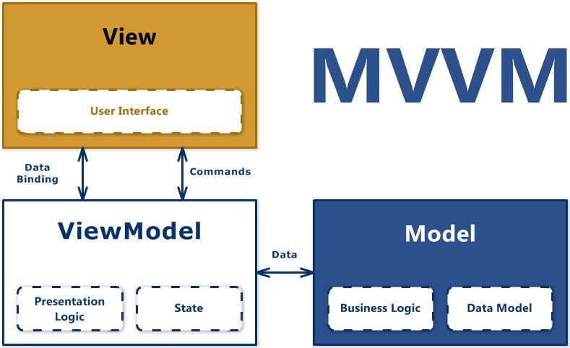
From a technological standpoint, the study aims to develop a cross-platform application using .NET MAUI (Multi-platform App UI), enabling a shared codebase that runs natively on Android, iOS, Windows, and macOS. This ensures accessibility across device types while reducing development complexity and long-term maintenance costs. The app will follow the Model-View-ViewModel (MVVM) architecture, promoting scalability, separation of concerns, and clean user interface logic.
Figure 1.1: Model-View-ViewModel (MVVM) Architecture
Key technical components of MANDUU will include:
- Frontend (Mobile App UI) using .NET MAUI and XAML for responsive, student-friendly interfaces.
- Backend API Layer developed with ASP.NET Core to handle user requests, vendor data, payment processing, and printing transactions.
- Database Layer using PostgreSQL to store user profiles, print requests, reviews, vendor listings, and transaction logs.
- Mobile Money Integration support for all major networks in Ghana (MTN MoMo, Telecel Cash, and AirtelTigo Money) with Visa/Debit Card and Bank transfer transaction as alternative payment options, to facilitate secure, cashless transactions.
- Google Maps API Integration to enable real-time location-based service discovery and navigation.
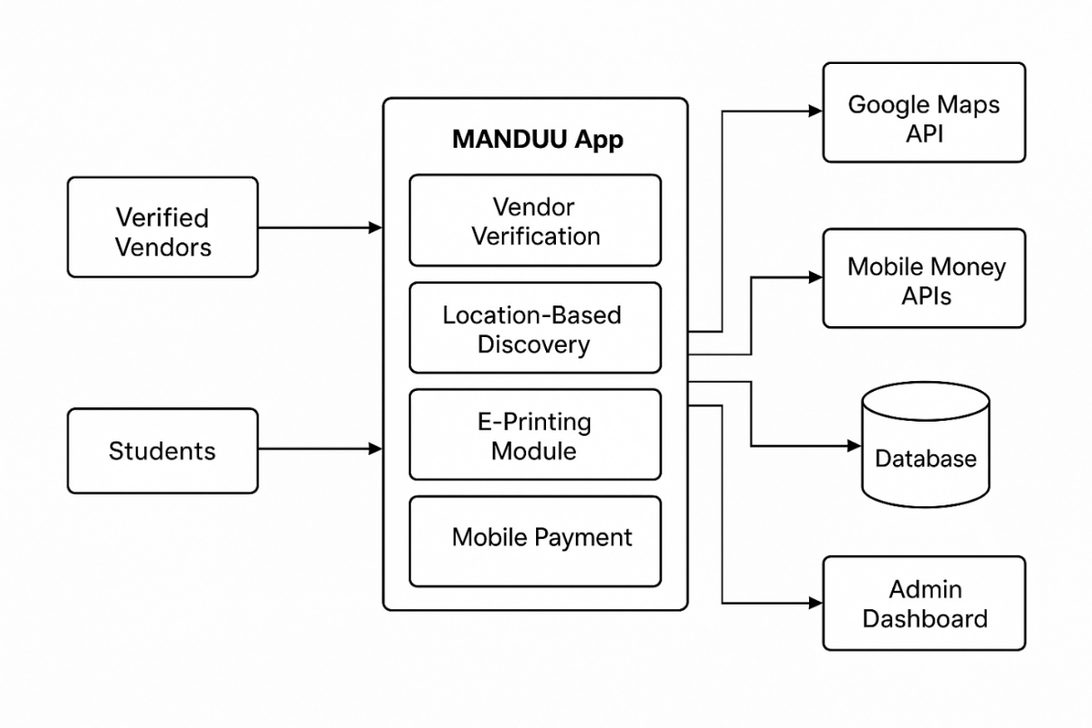
- Document Upload and Print Queue System, allowing students to submit files for printing and schedule pickup.
Figure 1.2: System Architecture of the MANDUU App

Research and Development Purpose
From a research perspective, this study aims to:
- Explore how digital trust mechanisms, such as vendor verification and review systems, influence user confidence in mobile commerce platforms.
- Investigate how location-awareness affects student service discovery behaviours in a closed geographic environment like a university campus.
- Evaluate the role of user-centred design in shaping usability and satisfaction for technology solutions deployed in academic communities.
- Contribute to the body of knowledge on mobile commerce and ICT for Development (ICT4D) by offering a case study on the intersection of informal economic activity, student needs, and localized mobile solutions in West Africa.
The project is theoretically grounded in the Technology Acceptance Model (TAM) (Davis, 1989), which posits that perceived ease of use and perceived usefulness are central to user adoption of digital systems. It also draws on McKnight et al.’s (2002) Digital Trust Framework, which provides a lens for understanding how credibility, security, and reputation influence user behaviour. Additionally, user-centred design principles (Norman, 1988) will guide the development process, ensuring that the system aligns with the real-world preferences and pain points of UCC students and vendors.

Social and Institutional Purpose
At a broader level, the study seeks to:
- Promote digital inclusion by equipping small-scale campus vendors with access to digital tools that can improve visibility, reduce dependency on physical presence, and expand business reach.
- Enhance student welfare by reducing stress, saving time, and making it easier to access campus-based services.
- Support university goals of digitization and entrepreneurship by offering a platform that can be institutionalized by the UCC Students’ Representative Council (SRC) or administration as a long-term student support service.
- Demonstrate a scalable model that other tertiary institutions across Ghana can adopt to enhance local service ecosystems.

Overall Aim
In summary, the purpose of this study is to show that a well-designed, location-based, and digitally secure mobile platform can transform campus commerce in Ghana from an inefficient, informal structure into a streamlined, trustworthy, and student-centred ecosystem. Through development, deployment, and empirical evaluation, the study aims to generate both a functioning prototype and evidence-based insights into mobile technology adoption in academic environments.

Objectives of the Study
The design and implementation of the MANDUU mobile marketplace app respond to well-defined challenges in accessing and organizing informal campus commerce at the University of Cape Coast (UCC). The project aims not only to build a working solution but also to generate insights into digital adoption, user-centred design, and platform-driven economic inclusion within a university context.
To guide this development and research process, the study is structured around a primary objective supported by multiple specific objectives that touch on both the technical system requirements and the research-based evaluation of usability, effectiveness, and potential scalability.

Main Objective
To design, develop, and evaluate a secure, cross-platform mobile application that connects verified campus vendors with students at UCC through location-based service discovery, integrated mobile payment options, and academic support services such as remote document printing.

Specific Objectives
- To design and implement a user-centred mobile interface using .NET MAUI:
The application must be visually intuitive and responsive across devices and operating systems. It should accommodate different user roles (students, vendors, administrators) with corresponding permissions and functionalities. The use of .NET MAUI ensures compatibility across Android, iOS, and Windows platforms through a unified codebase, reducing development time and enhancing maintainability.
- To establish a digital vendor onboarding and verification system:
One of the project’s key goals is to ensure transactional trust. This will be achieved by building a vendor registration module that requires credential submission, basic business profile information, and institutional validation. Only approved vendors will be allowed to list services, thereby addressing the persistent issue of unverified or fraudulent operators on campus.
- To integrate secure mobile payment systems within the application:
MANDUU will incorporate Ghana’s widely used mobile payment systems (MTN MoMo, Telecel Cash, and AirtelTigo Money), with Visa/Debit Card and Bank transfer transaction as alternative payment options. This objective seeks to enable cashless, fast, and verifiable transactions directly within the app. The integration must support secure user authentication, transaction history, and seamless payment confirmation for both students and vendors.
- To develop a location-based service discovery feature using the Google Maps API:
This feature is intended to allow students to identify service providers within their immediate campus zone. The system will enable filtered searches (e.g., document printing, hairstyling, laundry), view vendor locations on a map, and display estimated proximity to support efficient decision-making.
- To create a document upload and remote printing module:
Recognizing the high demand for academic printing services, the app will allow students to upload documents (e.g., assignments, handouts) and select preferred campus printing vendors. Students can specify printing options (e.g., page range, number of copies) and receive notifications when their documents are ready for pickup, thereby reducing congestion and time spent in queues.
- To implement a vendor dashboard for service management and performance monitoring:
This component will allow registered vendors to manage their services, track performance, resolve customer-related issues, and access usage analytics such as most-searched products and peak transaction periods.
- To conduct usability testing and performance evaluation of the system:
Beyond technical implementation, the study will employ user-centred evaluation techniques to assess the system’s practicality and adoption potential. Usability testing with a diverse group of UCC students and vendors will help measure satisfaction, navigation ease, perceived usefulness, and suggestions for future improvements.
- To analyse the impact of MANDUU on service access, trust, and transaction efficiency:
The final stage of the research will involve analysing how the platform alters the dynamics of campus service discovery, purchasing behaviour, vendor reach, and overall student satisfaction. This includes pre- and post-deployment comparisons, pilot feedback, and behavioural observations.

Research Questions
In line with the study’s objectives and the contextual challenges observed within informal campus commerce at the University of Cape Coast (UCC), the research is guided by key questions that explore the functional, behavioural, and technological dimensions of implementing a localized digital marketplace. These questions are structured to critically assess the system’s relevance, usability, trustworthiness, and potential to digitally transform campus-based economic interactions.
The research questions are grouped under thematic focus areas reflecting the core components of the application.

Addressing Access, Visibility, and Trust
- How do students currently discover and engage with campus vendors, and what barriers exist in terms of access, awareness, and vendor trust?
This question investigates the pre-existing service discovery landscape and evaluates how fragmented access affects student decision-making, safety, and vendor visibility.
- To what extent does a digital vendor verification system influence student confidence and willingness to transact in a mobile marketplace environment?
The goal is to determine how trust-building mechanisms such as registration approval, profile vetting, and user reviews influence platform adoption and repeat usage.

Evaluating Digital Transaction Behaviour and Security
- How do students and vendors perceive the integration of mobile money (e.g., MTN MoMo) within a campus-specific application?
This explores usability, perceived transactional security, and whether cashless payments are viewed as beneficial, convenient, and trustworthy in the campus context.
- Does the inclusion of real-time transaction tracking and receipts improve user satisfaction and accountability in informal vendor-student exchanges?
This question evaluates how digitization impacts the perceived legitimacy of small-scale vendors and enhances transaction transparency.
- Enhancing Service Efficiency and Academic Productivity
- What impact does a remote document upload and print queue system have on reducing congestion and improving service delivery at campus print shops?
This seeks to assess the extent to which the printing module alleviates physical queues and supports academic efficiency, especially during peak usage periods.
- In what ways does location-based filtering and mapping support more efficient decision-making among students seeking services across different zones of campus?
Here, the research evaluates whether the Google Maps–based interface genuinely improves service accessibility and balances demand among vendors.

User Experience and Platform Adoption
- What usability challenges arise during the interaction between users (students, vendors, administrators) and the MANDUU application?
This question will help identify design or performance flaws, navigation complexity, and areas where user expectations are not met.
- How do students perceive the overall effectiveness of a mobile marketplace platform in enhancing their academic and campus life experience?
- This addresses broader implications of the system on student satisfaction, convenience, time-saving, and potential for digital engagement.

Institutional and Entrepreneurial Opportunities
- Can a campus-specific marketplace platform support entrepreneurship among students and informal vendors by increasing visibility and transactional access?
This research seeks to explore the app’s potential for promoting economic inclusion and student-led innovation on campus.
- What are the institutional implications of digitizing campus commerce in terms of oversight, planning, and data-driven decision-making?
This question considers how usage analytics, vendor management, and platform governance can benefit university administration or student bodies (e.g., SRC).

Significance of the Study
The implementation of a secure, location-based mobile marketplace such as MANDUU is not only a technological innovation but also a socio-economic and academic intervention with the potential to transform how university communities’ function. The study is significant on multiple fronts: it provides a practical solution to the everyday challenges faced by students and campus vendors, offers academic contributions to research on digital trust and mobile commerce, supports the digital transformation efforts of educational institutions, and promotes entrepreneurial growth and digital inclusion.
As the University of Cape Coast (UCC) continues to expand its student population and its digital infrastructure, there is a growing need for contextually grounded solutions that address the unique nature of its informal service economy. The MANDUU platform, when effectively implemented, addresses this need through a holistic, user-centred approach.

Practical Significance
- Enhanced Accessibility and Service Discovery:
The app provides students with a centralized platform where they can easily locate essential services such as printing, hair grooming, laundry, and food sales without relying on inefficient and inconsistent methods like flyers or WhatsApp referrals. This improvement in access empowers students to make informed service decisions based on vendor proximity, availability, reviews, and credibility.

- Reduced Risk of Fraud and Exploitation:
With its built-in vendor verification system, MANDUU offers a safer environment for campus transactions. The platform ensures that only verified and authenticated service providers are listed, protecting students from fraudulent operators and low-quality service experiences that are common in unregulated informal markets.
- Time and Resource Efficiency:
Time is a critical resource for students. Through location-based filtering and the remote printing module, the application reduces time spent physically searching for services or standing in queues. This directly contributes to students' academic productivity and stress reduction, especially during high-pressure periods such as exam weeks.
- Financial Convenience and Security:
By integrating secure payment systems like MTN MoMo, Telecel Cash, and AirtelTigo Money, Visa/Debit Card and Bank transfer transaction, the app eliminates the need for students to carry cash or make physical withdrawals. This promotes safer transactions, limits theft and loss risk, and ensures smoother vendor-student exchanges. Additionally, digital receipts and transaction history features foster accountability and record-keeping.

Academic and Research Significance
- Filling a Localized Research Gap:
While mobile commerce has been extensively studied in Ghana, very few empirical studies have addressed the unique dynamics of informal university-based commerce ecosystems. This research contributes valuable data and case analysis on how students and vendors interact in a digitally underserved academic environment.
- Theoretical Contribution to Technology Adoption Research:
The project operationalizes models such as the Technology Acceptance Model (TAM) and the Digital Trust Framework, allowing the study to explore factors influencing adoption, such as perceived usefulness, ease of use, and trust. These frameworks help uncover how users in informal settings evaluate and accept digital platforms, enriching the existing body of knowledge.
- User-Centred Design Application:
By applying User-Centred Design (UCD) principles throughout the app’s development, the study contributes real-world insights into how student users perceive and interact with mobile systems tailored to their immediate context.
- Model for Future Research and Innovation:
The findings and outcomes from the MANDUU study can serve as a template or pilot for future digital innovation projects in Ghanaian higher education institutions, encouraging further research into scalable, inclusive, and trustworthy digital solutions for informal communities.

Institutional Significance
- Support for Campus Digital Transformation:
UCC and other public universities in Ghana are increasingly investing in digital infrastructure. MANDUU complements this institutional objective by offering a practical, user-driven platform that addresses real student and vendor needs. Its integration potential into existing university systems positions it as a valuable asset in the university’s digitization roadmap.
- Formalization of Informal Services:
By introducing digital verification, transaction tracking, and reviews, MANDUU begins to formalize informal vendor activity within campus boundaries. This can pave the way for official vendor registration programs, policy formulation, and structured support from campus management and student governance bodies.
- Promotion of Digital Entrepreneurship:
The platform fosters a culture of entrepreneurship by giving young vendors and student-run businesses visibility and access to a ready customer base. It enhances their capacity to scale, manage customer interactions, and receive structured feedback.

Socio-Economic and Developmental Significance
- Digital Inclusion for Marginalized Vendors:
Many campus vendors operate without access to the national e-commerce ecosystem due to technical literacy, financial constraints, or platform irrelevance. MANDUU provides a low-barrier entry point for these actors to engage in digital trade, extending the benefits of Ghana’s digital economy to underserved participants.
- Encouragement of Local Innovation:
The project demonstrates how localized digital tools can emerge from within the university environment to solve context-specific problems. It shows that students and academic institutions can be drivers of innovation, capable of addressing informal sector challenges using modern ICT frameworks.
- Potential for Scale and Replication:
Though initially developed for UCC, MANDUU’s architectural and operational model can be replicated across other tertiary institutions in Ghana and beyond. Its modular design supports scalability, while its low-bandwidth optimization ensures it remains accessible in areas with limited connectivity.

Limitations of Study
Although the MANDUU project is designed to address pressing issues in campus commerce through a technically robust and user-centred mobile solution, it is important to acknowledge the inherent limitations of the study. These limitations arise from the scope of academic research, development resource constraints, testing conditions, and dependencies on external services. They do not undermine the study’s significance but help contextualize its findings, define its boundaries, and highlight opportunities for future work.

Limited Scope of Deployment
Due to the nature of academic project timelines and budget limitations, the study is confined to the development of a functional prototype of the MANDUU mobile application. While the prototype will demonstrate the platform’s core capabilities, thus; including vendor discovery, mobile payments, document upload for printing, and user authentication, it does not constitute a fully industrial-grade, production-ready application.
Certain advanced features that would be expected in a live commercial deployment (e.g., real-time error recovery, auto-scaling infrastructure, full API rate handling, continuous integration pipelines) fall outside the scope of this study. Therefore, the system’s performance in high-volume usage scenarios or extended deployment periods cannot be fully evaluated in this research.

Narrow User Testing Population
User testing will be conducted with a selected sample of UCC students and informal vendors, which may not fully represent the full diversity of the campus population. Although every effort will be made to ensure demographic variation (e.g., in year group, faculty, or service type), the constraints of time and participant availability mean that the evaluation will be limited to a relatively small group.
The insights gathered such as questionnaire response, feedback on usability, trust, and feature preference will offer valuable direction but may not be generalizable to the entire UCC community or to other institutions. Broader studies with larger sample sizes and long-term engagement would be required for full generalizability and statistical validity.

Dependence on External APIs and Platforms
The functionality of key MANDUU features relies on third-party services including:
- Google Maps API – for vendor location mapping and user proximity detection,
- Mobile money APIs (MTN MoMo, Vodafone cash) – for in-app payments and transaction tracking,
- Cloud-based services (e.g., Firebase or third-party mail/notification APIs) – for sending alerts, account confirmations, or printing notifications.
This reliance introduces potential risks and constraints: service outages, rate limits, deprecated features, or changes in pricing or usage policies could affect the app’s operation. For example, reaching the usage quota for Google Maps APIs or encountering sandbox restrictions during mobile money testing may limit real-world evaluation of location and payment components.
Moreover, due to budget constraints, some services may only be tested using free-tier or sandbox environments, which can simulate but not fully replicate production-level behaviour.

Platform Compatibility and Device Limitations
The application will be developed using .NET MAUI to enable cross-platform compatibility; however, full universal device support cannot be guaranteed. Students and vendors may be using:
- Older Android devices that do not support the latest frameworks,
- iOS devices with outdated operating systems,
- Phones with limited RAM or processing power that may experience lag or crashes.
Testing will primarily focus on common student devices (mid-range Android smartphones), which means edge cases involving uncommon configurations or OS versions may go unaddressed during the study. This presents a technological limitation that may impact adoption, especially for users with lower-end devices.

Restricted Vendor and Service Type Coverage
While the application is designed to accommodate various types of campus vendors, the initial release will include only selected service categories, such as: Fashion, Grocery, Grooming and personal care, Food, Electronics and E-printing.
Other possible service domains are acknowledged but not included in this prototype version. Additionally, some vendors may not be willing or available to onboard during the pilot phase due to unfamiliarity with digital tools or scheduling conflicts, which may further limit vendor diversity during testing.

Constraints on Long-Term Impact Evaluation
Given that this study is conducted within the span of an academic year, it will not be possible to measure long-term behavioural, economic, or institutional impacts. For instance, vendor revenue changes, student service satisfaction over time, or university-level decision-making based on platform analytics would require longitudinal data gathered over multiple semesters. This limitation confines the evaluation to short-term indicators such as usability feedback, prototype stability, and initial user perceptions during pilot testing.
Furthermore, since the application will not be deployed for commercial use beyond the testing environment, opportunities to observe real-world competition, vendor retention, or market dynamics remain outside the scope of this research.

Institutional Integration Limitations
Although the MANDUU platform aligns well with UCC’s digitization goals and student entrepreneurship initiatives, this study does not formally engage with the administrative processes required for institutional adoption. This means:
- Integration into official university systems (e.g., student portals, payment gateways, campus IT infrastructure) will not occur in this research phase.
- There are no guarantees of post-project maintenance or administrative handover of the platform.
- Legal and policy frameworks governing digital platforms at UCC (e.g., data protection policies, formal vendor partnerships) will not be fully examined or incorporated.
Consequently, while the app offers a strong proof of concept, its post-project operational sustainability would require further institutional collaboration and policy alignment.

Delimitations of the Study
While the limitations of this study identify factors outside the control of the researcher, delimitations are the intentional boundaries set to define the scope, focus, and applicability of the research. These boundaries are put in place to ensure the feasibility of the project within academic timelines, resource availability, and the specific research objectives.
In this study, the design and evaluation of the MANDUU mobile marketplace are intentionally delimited to specific users, features, and institutional contexts in order to maintain focus, increase relevance, and ensure clarity in research outcomes.

Geographical Scope
The study is strictly limited to the University of Cape Coast (UCC) campus. This includes the primary academic and residential zones where student-vendor interactions are most concentrated. The app is designed to support service discovery, communication, and transactions only within this campus environment.
As such, vendors and students from other institutions, external communities, or commercial hubs in the broader Cape Coast Municipality are excluded from both the system design and evaluation phases.
This localized scope allows for:
- Context-specific development tailored to UCC’s infrastructure and culture.
- Simplified testing and feedback collection from a well-defined user base.
- Focused analysis of how digital tools perform in the micro-economy of a university campus.

Target Population
The study targets two core user groups:
- UCC students – as the primary users who will interact with the app to discover services, place orders, upload documents, and make payments.
- Verified campus vendors – small-scale service providers and student vendors who offer their services within the campus zone and are willing to participate in the digital platform.
Other user groups such as faculty, non-academic staff, external merchants, and national e-commerce stakeholders are excluded from this study. This ensures the system remains tailored to student needs and informal vendor dynamics on campus.

Functional Scope of the Application
The MANDUU application, as developed in this study, focuses on a specific subset of features that directly align with the needs and problems identified within the UCC campus context. These features include:
- Vendor registration and verification
- Student account creation and login
- Location-based service discovery
- Secure mobile payment
- Remote academic document printing
Other potential features that are relevant in broader e-commerce contexts but fall outside the study’s scope include:
- Inventory and order management for physical products
- Sales analytic dashboard
By restricting the functional scope, the study ensures that development efforts are concentrated on solving immediate and high-impact challenges relevant to the UCC setting.

Technological Frameworks and Tools
The development environment is intentionally delimited to .NET MAUI as the cross-platform framework of choice. This decision allows for:
- Unified codebase across Android, iOS, and Windows.
- Efficiency in development and maintenance.
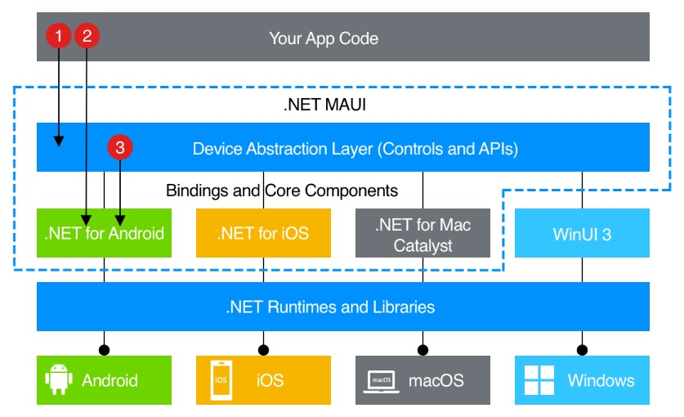
- Sufficient performance for prototype-level deployment.
Figure 1.3: .NET MAUI Framework Architecture for Cross-Platform App Development
Other frameworks such as Flutter, React Native, or native Android/iOS development tools are not considered in this project. Similarly, the backend and database tools are kept minimal and modular to facilitate focus on front-end usability and system integration testing.

Time Frame
The research is conducted within a single academic year (2024–2025). Consequently, only short-term evaluations (e.g., pilot testing, initial feedback sessions, simulated transactions) are conducted. Longitudinal analysis, seasonal trend tracking, and post-deployment economic impact studies are not included.
This temporal boundary helps ensure that project development, testing, documentation, and presentation are all realistically achievable within the final year project schedule.

Institutional Engagement
Although the study acknowledges the importance of university governance and long-term platform sustainability, this project does not attempt formal policy-level integration with the University of Cape Coast. As a student-led initiative, the research operates independently, with informal consultation where needed (e.g., through the Students’ Representative Council or faculty supervisors).
Institutional legal compliance, data-sharing agreements, or stakeholder memoranda are thus outside the scope of the current study. However, the final prototype is designed with potential institutional adoption in mind.

CHAPTER 2: LITERATURE REVIEW

Introduction
University campuses are compact, high-frequency marketplaces where students repeatedly need everyday services that are too often supplied through informal, fragmented channels. This fragmentation produces practical problems and campus-specific mobile marketplaces that have the potential to address these problems by combining vendor verification, location-aware discovery, and secure payment flows to improve convenience, transparency, and safety (Akanferi et al., 2022; Hubtel, 2024). Yet most mainstream commercial platforms are designed for broad audiences and lack campus-oriented features such as geo-fencing, university-verified vendor onboarding, and academic workflows like remote e-printing—features that empirical studies and campus pilot projects identify as critical for real adoption (Petcovici & Stroulia, 2016; Lee et al., 2015).
Successful adoption of such platforms depends not only on technical capability but also on user perceptions of usefulness, ease of use, and trust. The Technology Acceptance Model (Davis, 1989) and subsequent digital trust frameworks emphasize that perceived benefits and clear verification mechanisms strongly influence whether students and vendors will adopt a new app. In the Ghanaian context, growing mobile-money uptake and broad smartphone penetration create a favourable technological environment, but studies point to persistent concerns around security, privacy, and sustained behavioural change that must be addressed through design and verification (GSMA, 2023; Afful & Palaniappan, 2023; Yeboah et al., 2020).
This chapter reviews literature across five interrelated areas: campus marketplaces and student-focused commerce; mobile payments and security in Ghana; vendor verification and trust-building in informal economies; location-based discovery and geo-services for campuses; and integration of academic services (with emphasis on remote printing workflows). Each section draws comparisons between global implementations and the Ghanaian/university context, highlights methodological approaches used by prior studies, and identifies gaps that the proposed MANDUU application aims to fill at the University of Cape Coast (UCC).

Digital Marketplaces in Campus Contexts
Robiin and Pujiyono (2020) designed and evaluated a campus-centred marketplace called Campus Stalls, which allowed students to post and browse listings for goods and services within their university. The study showed that a dedicated student marketplace could significantly improve the visibility of offerings and reduce the time spent searching for vendors compared to relying on word-of-mouth or noticeboards. Their usability testing revealed that students appreciated the streamlined categorisation of listings and the user-friendly interface. However, the platform was essentially a classified ads system that ended transactions offline. It did not provide integrated, secure payment capabilities, lacked any mechanism to verify vendors through the university, and entirely omitted academic service modules such as printing, tutoring, or room booking. In a campus like UCC where informal vendors dominate and where students frequently require both commercial and academic services these limitations reduce the platform’s potential impact. Hence, MANDUU goes further by embedding mobile-money payment gateways, integrating a university-administered vendor verification process, and including academic workflows like secure remote e-printing within the same platform, enabling students to complete an entire transaction seamlessly from discovery to payment to service delivery.
Petcovici and Stroulia (2016) developed a location-based services (LBS) platform for a smart campus, enabling service discovery filtered by proximity. Their experiments showed that narrowing search results to a user’s walking radius or specific campus zones reduced irrelevant matches and improved task completion times. Such geo-scoping proved valuable in helping users quickly locate relevant services. However, their system was tested in high-connectivity, well-resourced environments with fixed service points and formal campus IT infrastructure. These assumptions do not hold in UCC’s context, where connectivity can be intermittent, many vendors are mobile (changing locations during the day), and the majority operate outside formal IT frameworks. For this reason, MANDUU implements a hybrid LBS system: it uses GPS when available but also offers a manual “search by building or zone” option to cater to low-end devices and low-data users. Vendors can register multiple operating zones and update their location dynamically, ensuring discoverability even when they move across campus throughout the day.
Lee, Yeh, Yang, Moon, and Choi (2015) presented a secure NFC-based mobile printing system allowing students to upload documents remotely and collect them at designated printers after authentication. Their work demonstrated that such systems reduce queue times and prevent unauthorised access to printed documents. However, their design assumed that printing services were centralised, institution-owned, and supported by a unified IT infrastructure, conditions that do not exist at UCC, where printing is largely handled by independent, small-scale vendors with limited resources. Therefore, MANDUU adapts the remote printing concept for decentralised environments. Instead of relying on campus ID cards or NFC kiosks, MANDUU generates a secure one-time PIN or OTP code sent to the user after payment. This code is verified by the vendor at pickup, offering a low-cost but secure authentication method that works with the tools vendors already have — mainly smartphones with internet access.
Akanferi et al. (2022), Afful and Palaniappan (2023), and the GSMA (2023) collectively document the rapid growth of mobile-money adoption in Ghana, noting that perceived usefulness, transaction security, and ease of use are key adoption drivers. Their findings confirm the technical feasibility of integrating local payment channels like MTN MoMo into service platforms. However, these studies examine mobile-money use in broad, often formal-sector contexts, without focusing on the specific challenges of integrating payments into a campus marketplace that also manages academic services and informal vendor relationships. Accordingly, MANDUU embeds mobile-money directly into the marketplace’s transaction flow, linking every payment to a vendor’s verification badge and issuing instant, itemised receipts to both buyer and seller. This integration strengthens user trust while reducing disputes.
Yeboah et al. (2020) highlight the importance of visible trust signals such as verified identities and public ratings in encouraging merchant adoption of digital payment systems. Their study demonstrates that such trust mechanisms can increase adoption rates in Ghana’s retail sector. However, they do not describe how to adapt these trust signals for university marketplaces dominated by informal vendors. Consequently, MANDUU implements a lightweight onboarding process that verifies vendor identity and affiliation with UCC before awarding a verification badge. Vendors’ transaction histories and ratings are then displayed on their profile, giving students a combination of institutional assurance and peer feedback when deciding where to purchase services.

Gap Summary for Digital Marketplaces
The reviewed literature confirms that campus-focused marketplaces can improve service discoverability, LBS can reduce search friction, and mobile-money is widely adopted in Ghana. However, existing studies typically address only one function in isolation; marketplace listings, location-based filtering, or e-printing, and often assume formal, well-funded infrastructure that is not present at UCC. There is a lack of integrated solutions that combine a marketplace, remote e-printing, secure mobile payments, and vendor verification, all tailored to informal vendor environments and low-bandwidth conditions. MANDUU fills these gaps by:
- Combining commercial and academic services into one platform.
- Offering hybrid LBS for fixed and mobile vendors.
- Integrating secure payments with vendor verification.
- Using low-resource-friendly design to suit UCC’s technological constraints.

Mobile Commerce and Payment Adoption in Ghana
Akanferi, Asampana, Matey, and Tanye (2022) examined mobile commerce and mobile payment adoption among Ghanaian public servants using the Technology Acceptance Model (TAM). Their study revealed that perceived usefulness, ease of use, and trust significantly influenced the intention to adopt mobile commerce platforms. They also noted that users were more likely to adopt platforms that offered intuitive navigation, clear service benefits, and visible security assurances. However, their research focused on a very specific segment of the population whose purchasing behaviours, budget considerations, and trust perceptions differ from those of students operating in a campus micro-economy. It also did not explore integration with multi-service environments that combine academic and non-academic services. To address this, MANDUU tailors its payment system to the needs of students and informal campus vendors: it supports low-value, high-frequency transactions, includes simplified payment flows optimised for mobile use, and embeds trust signals (vendor verification badges and visible ratings) directly into the payment process.
Afful and Palaniappan (2023) explored factors influencing the continued usage of mobile money in Ghana, identifying service reliability, transaction transparency, and security as crucial for retaining users. Their study highlighted the importance of encryption, detailed receipts, and dispute resolution mechanisms in sustaining user engagement. However, the focus of their work was on sustaining adoption in general commerce rather than encouraging initial adoption in integrated, campus-specific service platforms. They did not consider scenarios where mobile-money transactions are part of a broader service interaction, such as paying for a print job or reserving a tutoring slot within the same app. For this reason, MANDUU embeds mobile payments into the end-to-end workflow of each service category. For instance, when a student books a printing service, payment is collected in-app, a receipt is generated instantly, and the job is automatically linked to a vendor dashboard, creating a seamless, transparent chain from payment to service fulfilment.
The GSMA (2023) State of the Industry Report on Mobile Money documents Ghana’s high mobile-money penetration rate, noting a steady increase in transaction volumes and a growing trend towards interoperable services across different providers. The report positions Ghana as one of the most mature mobile-money markets in Sub-Saharan Africa, with strong consumer familiarity and infrastructure support. However, while this readiness is encouraging, the report focuses on national and regional transaction data, which largely reflects formal-sector commerce and high-value transactions. It does not address micro-transactions such as 50-pesewas printing charges or small snack purchases that dominate campus economies, nor does it discuss the unique trust dynamics between students and informal vendors. Hence, MANDUU is designed to optimise for micro-transactions: it uses transaction batching to minimise fees where possible, issues instant receipts for even the smallest payments, and provides a built-in dispute resolution mechanism specifically suited to campus-scale interactions.
Yeboah, Boateng, Owusu, Afful-Dadzie, and Ofori-Amanfo (2020) studied merchant adoption of mobile payments in Ghana, concluding that vendor perceptions of transaction security and customer trust strongly influence their decision to accept digital payments. They emphasised that merchants are more willing to participate when they believe customers trust them and the platform mediating the payment. However, their analysis focused on general retail merchants and did not examine university-affiliated vendor ecosystems, where personal relationships, campus reputation, and informal social networks often play a bigger role in shaping trust. This is why MANDUU integrates university-linked vendor verification and allows students to view a vendor’s transaction history and rating before making a payment — measures that address both perceived and actual trustworthiness in the unique context of a university campus.
Hornuf, Safari, and Voshaar (2024) conducted a meta-analysis of mobile fintech adoption in Sub-Saharan Africa, identifying common adoption barriers such as regulatory uncertainty, low digital literacy among certain user groups, and persistent security concerns. While their synthesis provides valuable regional context, it does not offer design recommendations for constrained environments like UCC, where intermittent internet access, low-spec devices, and cost-sensitive users are the norm. As a result, MANDUU prioritises lightweight, offline-friendly payment flows and uses simple, icon-driven interfaces to make payment navigation easier for all users, including those with minimal prior experience in mobile app transactions.

Additional Studies to Broaden Evidence Base
Mensah and Aboagye (2021) investigated mobile payment adoption among Ghanaian university students, finding that affordability of transaction fees and peer influence significantly shaped uptake. Their study was limited to food purchases and did not explore integration with academic services or vendor verification. Accordingly, MANDUU incorporates affordable, micro-payment-friendly options across multiple service categories from food orders to printing while tying payments to verified vendor profiles.
Boateng and Doku (2019) examined mobile wallet security perceptions in Ghana, finding that students value transparent dispute resolution and transaction traceability. However, they did not assess how such mechanisms could be embedded into integrated service platforms. To address this, MANDUU includes a dispute resolution workflow in its payment system, allowing students to flag transactions and resolve issues within the app.

Gap Summary for Mobile Commerce in Ghana
The reviewed literature confirms that Ghana’s mobile-money ecosystem is mature and technically capable of supporting digital payment integration. However, most existing studies focus on general populations, formal retail settings, or high-value commerce. They rarely address the specific challenges of integrating mobile payments into campus service marketplaces serving informal vendors and students engaged in micro-transactions. There is also limited guidance on designing payment features that function reliably in low-bandwidth conditions and link directly to vendor verification mechanisms. MANDUU addresses these gaps by embedding secure, receipt-based mobile-money transactions within a platform tailored to the campus micro-economy, optimising for affordability, transparency, and trust-building in the UCC context.

Trust, Vendor Verification and Informal Economies
Trust is consistently identified as one of the most decisive factors in the adoption of digital platforms, particularly in environments where many transactions involve informal vendors who lack formal business credentials. In such cases, users are more likely to engage with platforms that visibly demonstrate vendor legitimacy, provide transparent feedback mechanisms, and maintain secure transaction records. This is especially relevant in the Ghanaian campus context, where informal economies dominate service provision, and both vendors and customers rely heavily on reputation and social proof.
McKnight, Choudhury, and Kacmar (2002) developed a widely cited digital trust framework identifying structural assurance, situational normality, and trusting beliefs as key determinants of a user’s initial trust in a digital service. Their model provides a theoretical basis for designing verification and trust-building processes, showing that clear institutional backing and predictable platform behaviour can substantially increase user confidence. However, the framework does not provide practical, operational guidelines for onboarding and verifying small-scale, informal vendors in a university environment. It assumes the presence of formal documentation, stable regulatory frameworks, and fixed business locations — all of which are often absent in UCC’s vendor ecosystem. This is why MANDUU translates these trust principles into operational features: a vendor onboarding process that requires lightweight identity verification (e.g., national ID plus proof of campus affiliation) and a university-administered approval system that issues verification badges to vendors once approved. These badges are visible to students at every interaction point, creating an immediate trust signal consistent with McKnight’s “structural assurance” principle.
Yeboah, Boateng, Owusu, Afful-Dadzie, and Ofori-Amanfo (2020) studied merchant adoption of mobile payments in Ghana and concluded that perceived transaction security and customer trust strongly influence merchant participation. They emphasised that merchants need assurance that customers believe in the safety of the system before they are willing to accept digital payments. However, their study focused on general retail merchants and did not examine the dynamics within a university campus, where vendor–customer relationships are often informal and mediated through peer networks rather than formal business channels. Therefore, MANDUU integrates vendor verification directly into its payment system, ensuring that students can see a vendor’s verification status, transaction history, and aggregated ratings before initiating payment. By doing so, it addresses both sides of the trust equation: the vendor’s willingness to join and the customer’s willingness to transact.
Chin, Harris, and Brookshire (2018) investigated how perceived risk and trust influence mobile app installation decisions. They found that visible security assurances, credible platform branding, and consistent positive reviews reduced user hesitation. However, their study was primarily consumer-focused and did not extend these trust considerations to the vendor side. They also did not consider institution-backed trust mechanisms, which can be particularly influential in closed environments like universities. That is precisely why, MANDUU complements consumer trust-building measures (secure payment processing, encrypted communications, OTP verification) with institutional trust anchors such as university-administered vendor badges and periodic vendor re-verification, reinforcing confidence in both directions of the transaction.
Poudel, Acharya, and Simkhada (2023) explored the role of security and privacy in building customer trust in e-payment systems, finding that encryption and clear privacy policies are critical adoption drivers. While their findings are directly relevant to MANDUU’s design, particularly the emphasis on SSL/TLS encryption and strict data-handling policies, their focus was entirely on the customer side, neglecting the vendor’s need for trust in the platform and its users. In light of this, MANDUU builds symmetrical trust mechanisms: customers receive assurances about vendor legitimacy, and vendors gain transparency on customer orders, payment guarantees, and dispute resolution processes.
The Women in Informal Employment: Globalizing and Organizing (WIEGO, 2021) report highlights that informal vendors in Ghana often struggle with digital visibility and face systemic trust deficits, making it difficult for them to compete with more formal service providers. The report stresses the need for recognition and inclusion mechanisms that allow informal vendors to participate in digital marketplaces. However, it stops short of offering a blueprint for how to implement such mechanisms in a university context where informal vendors operate under unique cultural, logistical, and administrative constraints. Consequently, MANDUU incorporates digital inclusion strategies specifically designed for UCC: creating low-barrier onboarding procedures, offering vendor profile pages with photographs and service descriptions, and allowing vendors to showcase reviews and repeat customer rates to build credibility over time.

Additional Studies to Broaden the Evidence Base
Osei and Addo (2020) examined trust in online peer-to-peer marketplaces in Accra, finding that seller ratings significantly improved buyer confidence. However, they did not address how such systems could be institutionally validated. Therefore, MANDUU combines user-generated ratings with university verification, ensuring that ratings are supported by confirmed vendor identities.
Nkansah and Sackey (2022) studied digital inclusion among informal workers in Ghana, showing that basic training on platform use increased vendor participation rates. However, they did not explore integrating such training with trust mechanisms in multi-service campus apps. Consequently, MANDUU offers onboarding support alongside its verification process, helping vendors not only join the platform but also understand how to maintain their credibility.

Gap Summary for Trust and Vendor Verification:
The literature clearly shows that verification, security assurances, and reputation systems are key to fostering trust in digital platforms. However, most studies focus either on consumers or on formal merchants, leaving a gap in practical guidance for designing verification systems that work for informal campus vendors. There is also little discussion on embedding these systems within multi-service platforms that combine commercial and academic offerings. MANDUU addresses these gaps by operationalising a vendor verification system that is low-cost, scalable, and credible, pairing it with transaction histories, customer ratings, and secure payments. This ensures that both students and vendors can participate confidently in UCC’s informal campus economy.

Location-Based Services and Geo-Fencing for Campuses
Location-based services (LBS) and geo-fencing technologies have become central to many smart-campus prototypes and mobile commerce platforms because they address one of the most practical realities of campus life: the spatial proximity of goods, services, and users. In a university setting, time and location are critical decision factors: students often need to know what is available and how close it is before committing to a purchase or service.
Petcovici and Stroulia (2016) implemented a geo-scoped discovery system for a smart campus, allowing users to search for services filtered by walking radius or building zones. Their study found that geo-fencing and campus-specific mapping reduced irrelevant results, shortened the time needed to find services, and improved overall user satisfaction. However, their system was evaluated in an environment with stable GPS accuracy, robust Wi-Fi coverage, and fixed service locations — conditions not representative of many Ghanaian campuses. At UCC, GPS signals may be inconsistent due to dense building layouts, mobile data coverage can be unreliable, and many vendors are mobile, changing their location throughout the day. MANDUU on the other hand uses a hybrid approach: while GPS is supported for those with compatible devices and data plans, the app also offers a manual “search by building or zone” feature that does not rely on constant location tracking. Vendors can pre-register multiple operating zones (e.g., “Science Complex in the morning” and “Library forecourt in the afternoon”) and switch between them as needed, ensuring they remain visible to customers regardless of movement or connectivity challenges.
Commercial LBS implementations in global contexts often rely heavily on continuous GPS polling and online map rendering (e.g., Google Maps API integration) to update vendor positions in real time. While effective in high-bandwidth environments, such approaches increase mobile data consumption and drain battery life, two major concerns for students in Ghana who often operate on limited data bundles and lower-end devices. Hence, MANDUU offers low-data alternatives, such as offline map tiles and simplified geohash-based location encoding, which store and retrieve location data in a compact form. This design minimises the need for constant network requests and allows the platform to function even when the user is temporarily offline.
Privacy concerns are another recurring theme in the LBS literature. Users may resist fine-grained tracking unless location data collection is transparent, explicitly consented to, and clearly tied to tangible service benefits. Research shows that platforms perceived as over-intrusive often experience higher drop-off rates (Petcovici & Stroulia, 2016; Chin et al., 2018). Accordingly, MANDUU adopts a privacy-preserving approach: location sharing is strictly opt-in, with clear justifications for why location data is requested. Students can choose between precise GPS location, building-level location, or fully manual selection, depending on their comfort level.
Alternative positioning methods such as Bluetooth Low Energy (BLE) beacons, Wi-Fi fingerprinting, or hybrid indoor positioning systems have been explored in the literature as ways to improve accuracy in indoor spaces where GPS struggles. While these methods can be highly accurate, they require significant infrastructure investment and maintenance, which is rarely feasible in low-resource contexts. Few, if any, studies have evaluated the effectiveness of such approaches in African university campuses where infrastructure deployment is constrained by cost and logistical hurdles. MANDUU avoids infrastructure-heavy solutions and instead focuses on adaptable, low-maintenance strategies that can be deployed immediately without requiring new hardware installations.
Another underexplored challenge in the literature is accommodating mobile vendors: those who do not have a permanent location but operate along certain routes or in shifting spots depending on the time of day. Most LBS designs assume fixed coordinates for each vendor, which can render mobile vendors invisible when they leave their “registered” location. MANDUU addresses this by allowing vendors to update their operating location on-the-fly via the vendor dashboard and by enabling them to list recurring movement patterns (e.g., “Old Site Canteen in the morning, Atlantic Hall area in the afternoon”). This ensures that even mobile vendors remain discoverable without requiring continuous GPS broadcasting.

Gap Summary for LBS on UCC
The literature confirms that LBS can significantly improve service discovery and reduce search friction, but most systems are designed for stable, high-connectivity environments with fixed vendor premises. They rarely address low-bandwidth optimisation, privacy-preserving consent flows, or the challenges of supporting mobile and informal vendors. MANDUU closes these gaps by:
- Using a hybrid location system (GPS + manual zone selection) that works under poor connectivity.
- Implementing low-data map options and offline caching to minimise data costs.
- Offering privacy-preserving, opt-in location sharing options.
- Supporting mobile vendor operations through multiple pre-registered zones and real-time location updates.

Remote E-printing Integration
Remote e-printing has become an established feature in many well-resourced universities worldwide, allowing students to upload documents from their personal devices, have them queued on a central print server, and then release them securely at a designated printer. This model reduces congestion during peak times, improves service convenience, and provides accountability for print usage. Industry solutions such as Wēpa and PaperCut demonstrate measurable reductions in queue times, streamlined file handling, and cost recovery benefits through integrated payment systems. These solutions also typically offer safeguards like virus scanning, file format validation, secure release codes, and notifications when jobs are ready.
Lee, Yeh, Yang, Moon, and Choi (2015) contributed to the academic understanding of e-printing by presenting a secure NFC-enabled mobile printing service. In their design, students could upload documents from their devices, authenticate themselves at the printer using NFC, and securely release the document for printing. This model provided strong security, reduced wait times, and improved the user experience for document handling. However, their system assumed that printers were institutionally owned, centrally managed, and tied into formal campus identity systems (such as smart cards or single sign-on authentication). In the University of Cape Coast (UCC) context, most printing services are delivered by independent, small-scale vendors, many of whom work with limited resources and without formal IT integration. This makes NFC-based centralised infrastructure impractical. It is in response to this that MANDUU adapts the secure printing workflow to a decentralised, vendor-driven model, enabling independent vendors to receive print jobs directly through their own devices. Secure pickup is enforced through one-time PINs or OTP codes sent to customers after payment, ensuring that only the rightful owner can collect the printed documents.
A major challenge in adapting remote e-printing to the Ghanaian campus context is the absence of institutional identity integration for informal vendors. Commercial solutions rely on campus-wide authentication systems like ID cards or student portals to validate print releases. Informal vendors do not have access to such systems. As a result, MANDUU implements lightweight, platform-based verification: students verify themselves via their registered MANDUU account, and jobs are linked to that account with a unique code. Vendors verify the code at pickup, ensuring the transaction remains secure without requiring institutional IT dependencies.
Another barrier is network and device constraints. Many students in Ghana use low-end smartphones and purchase mobile data in small bundles, making it difficult to upload large files to a remote server. Likewise, vendors may have intermittent connectivity or limited storage capacity. Existing e-printing literature assumes consistent connectivity and large bandwidth allowances, which does not reflect UCC’s reality. Therefore, MANDUU integrates several low-bandwidth strategies:
  - Automatic file compression to reduce upload sizes.
  - Chunked uploads to handle large files on slow networks.
  - Optional offline submission workflows where jobs can be queued locally until a stable connection is available.
Vendor-side workflows in most published e-printing systems also assume staff operate from desktop computers with a constant internet connection. Informal vendors at UCC often run their businesses entirely from smartphones. Therefore, MANDUU offers a lightweight, mobile-friendly vendor dashboard where they can view incoming print jobs, see payment confirmations, mark jobs as complete, and send pickup notifications, all without requiring desktop hardware or high-speed connections.
Security and privacy are also under-discussed in informal vendor contexts. Enterprise printing systems typically have built-in malware scanning, temporary file storage, and automatic deletion of documents after printing. Informal vendors do not have such infrastructure, which increases the risk of document leakage or unauthorised reprints. Hence, MANDUU routes all documents through a secure, encrypted channel, with automatic file deletion from the vendor interface after the job is marked as collected. This protects both students and vendors while maintaining operational simplicity.
Finally, the literature largely treats e-printing as a standalone service or as part of a centralised IT system. There is little research on integrating it into a multi-service platform that also handles food orders, laundry pickups, and tutoring bookings. Yet on campus, students often need to perform these tasks in quick succession and expect a seamless, unified experience. Accordingly, MANDUU embeds remote e-printing into its broader marketplace framework. A student can, in the same session, order lunch, upload a print job, and schedule a laundry pickup with all payments, receipts, and vendor ratings managed through a single account.

Gap Summary for Remote E-Printing
Existing studies and systems confirm the operational benefits of remote e-printing (reduced queues, improved convenience, and better security) but they generally assume centralised infrastructure, stable connectivity, and integration with institutional identity systems. These assumptions do not hold in UCC’s informal-vendor-driven context. The key gaps are:
- Lack of integration between printing and other campus services.
- Absence of vendor workflows suitable for mobile-only operations.
- Insufficient attention to low-bandwidth file handling.
- Missing payment, dispute resolution, and verification mechanisms suited to micro-transactions.
MANDUU addresses these by:
- Embedding printing as one module within a multi-service marketplace.
- Enabling mobile-first vendor job management with lightweight tools.
- Supporting offline and low-bandwidth file submission.
- Using secure, OTP-based pickup verification.
- Linking all print transactions to secure mobile-money payments and vendor verification for transparency and trust.

Usability, Technology Acceptance (TAM) and Evaluation Approaches
Usability and technology acceptance are critical determinants of whether a system will be adopted and sustained in a campus setting. Even when a platform offers technically advanced features, it will fail if users find the interface confusing, the workflows too complex, or the benefits unclear. In multi-service platforms such as MANDUU, where different functions (marketplace, payments, LBS, and remote printing) must work together smoothly, usability is not simply about individual feature performance but also about how well these features integrate into complete user workflows.
The Technology Acceptance Model (TAM) introduced by Davis (1989) identifies perceived usefulness and perceived ease of use as the two most important predictors of behavioural intention to adopt technology. According to TAM, users are more likely to accept and regularly use a system if they believe it will improve their performance and if they find it straightforward to operate. This model has been applied across numerous technology adoption studies, including mobile apps and e-commerce systems, confirming its relevance in assessing both functional value and user experience. However, most TAM applications in the literature focus on single-service systems and do not evaluate complex, multi-step workflows that combine commercial, academic, and trust-building functions, a gap that directly applies to MANDUU. In light of this, MANDUU adopts TAM not only to assess each individual module but also to evaluate the overall end-to-end experience of performing multi-step tasks, such as discovering a vendor, making a payment, and collecting a printed document, all in one continuous flow.
Afif (2023) evaluated students’ perceptions of mobile application usability using the System Usability Scale (SUS), a widely adopted instrument for quantifying perceived ease of use and satisfaction. Afif’s study demonstrated that SUS scores correlate strongly with qualitative feedback on learnability and user satisfaction. However, while SUS effectively captures general usability, it does not directly assess perceptions of trustworthiness, security, or service reliability — factors that are especially important in digital marketplaces involving payments and personal data. In light of this, MANDUU complements SUS testing with trust and security perception scales adapted from McKnight et al. (2002), ensuring that both functional usability and user confidence are measured.
Lumor, Pulkkinen, and Hirvonen (2020) studied actual adoption and continued use of campus mobile apps, highlighting the importance of longitudinal, real-world testing rather than relying solely on short-term lab evaluations. They found that certain usability challenges such as slow performance during peak usage, feature discoverability issues, or drop-offs in engagement, only emerged when systems were tested over weeks or months in real campus environments. However, their work still focused on apps with narrow functions (e.g., course registration or timetable viewing) rather than integrated service platforms. To address this, MANDUU plans a multi-phase evaluation process:
- Participatory design workshops with students and vendors to align system features with real needs.
- Lab-based usability tests (including think-aloud protocols and SUS scoring) to refine interface design.
- Pilot deployments on campus, collecting event logs, performance metrics, and user feedback over time.
- Follow-up qualitative interviews with both students and vendors to capture operational issues, trust perceptions, and suggestions for improvement.
Research on usability evaluation often assumes stable network conditions and modern devices, which is not the reality for many UCC students. Low-bandwidth networks and low-spec smartphones can significantly affect performance, load times, and even feature accessibility. These constraints are rarely factored into usability testing in existing studies. For this reason, MANDUU will intentionally conduct usability trials under realistic campus conditions, including on low-cost Android devices and during periods of heavy network traffic, to ensure that the system performs well for the majority of students.
Another overlooked aspect in the literature is the usability of trust-related features. Vendor verification badges, dispute resolution interfaces, and secure payment confirmations all influence user perception and behaviour, but few studies measure how easily users can interpret and use these features. To address this, MANDUU includes task-based usability testing specifically for trust functions for example, measuring how quickly a student can identify whether a vendor is verified, or how easily they can initiate a payment dispute.

Gap Summary for Usability and Evaluation
The literature converges on the value of combining quantitative usability measures (e.g., SUS) with qualitative feedback and field testing. However, there is a gap in evaluating integrated, multi-service platforms in low-resource campus environments, especially regarding end-to-end workflows and trust-related features. MANDUU addresses this gap through a structured evaluation strategy that:
- Combines TAM-based adoption analysis with usability and trust perception metrics.
- Tests the entire service chain from discovery to fulfilment, not just individual functions.
- Includes field testing under realistic campus conditions, including low-bandwidth and low-device-performance scenarios.
- Explicitly measures the usability of trust and verification features alongside core service functionality.

Critical Comparison with Related Work
The development of MANDUU builds directly on existing research and implementations across digital marketplaces, mobile commerce, location-based services, academic service integration, and usability evaluation. Each of these prior works offers valuable insights, but none fully addresses the integrated, campus-specific needs of the University of Cape Coast (UCC). This section compares key studies and systems, highlighting their contributions, identifying the specific gaps, and explaining how MANDUU addresses those shortcomings in its design.
Robiin and Pujiyono (2020) created a web-based campus marketplace aimed at improving the accessibility of goods and services among students. Their system successfully facilitated transactions, improved service discovery, and demonstrated that a university-specific marketplace can encourage student participation. However, their approach was limited to classified-style advertisements where payments and service fulfilment occurred offline. It lacked secure digital payment integration, vendor verification tied to institutional authority, and academic service modules such as remote e-printing. How MANDUU addresses this gap: MANDUU integrates all these missing elements. It embeds mobile-money payment processing into the marketplace flow, includes a university-administered vendor verification process, and supports academic workflows (e.g., uploading and paying for print jobs within the same app). This transforms the marketplace from a passive listing board into a complete transaction platform with built-in trust mechanisms.
Petcovici and Stroulia (2016) developed a location-based service platform for smart campuses, enabling geographically scoped service discovery and reducing irrelevant search results. Their work demonstrated that spatial filtering can significantly improve findability and service uptake. However, the system was designed for high-connectivity environments with reliable GPS accuracy and fixed service points: conditions that do not align with UCC’s context of intermittent network coverage and mobile vendor operations. How MANDUU addresses this gap: MANDUU incorporates adaptive location detection, combining GPS-based search with manual zone or building selection to accommodate low-end devices and connectivity challenges. Vendors can register multiple locations or change their active zone dynamically, ensuring visibility even for those who move across campus throughout the day.
Lee et al. (2015) presented a secure NFC-enabled mobile printing service that demonstrated efficiency gains and improved document confidentiality. Their prototype confirmed that remote printing with secure release can reduce queues and improve service convenience. However, the system relied on a centralised IT-managed infrastructure, fixed printing stations, and integration with campus authentication systems, which is not feasible for UCC’s network of independent printing vendors. How MANDUU addresses this gap: MANDUU decentralises the printing model, allowing informal vendors to manage print orders directly from their smartphones. Secure pickup is ensured via OTP or PIN verification, eliminating the need for expensive NFC kiosks or institutional identity cards while maintaining strong document security.
Akanferi et al. (2022) and Afful and Palaniappan (2023) explored the adoption of mobile commerce and payment systems in Ghana, emphasising the roles of trust, usefulness, and ease of use in encouraging uptake. These findings underline the importance of seamless, transparent payment experiences. However, their studies focused on formal retail environments and general consumer populations, overlooking the unique characteristics of campus micro-economies — small, frequent transactions; student-vendor relationships; and the integration of academic services into the same platform as commercial ones. How MANDUU addresses this gap: MANDUU is designed for micro-payments, enabling transactions as small as a single-page print job or a quick snack purchase. Payments are processed instantly, with digital receipts generated for both buyer and seller, reinforcing transparency and record-keeping.
Yeboah et al. (2020) examined merchant adoption of mobile payments in Ghana, finding that trust was a key adoption driver. They concluded that visible credibility markers and customer trust could increase merchant participation in digital transactions. However, their research provided limited insight into how informal campus vendors could be incorporated into verified marketplaces without raising participation barriers. How MANDUU addresses this gap: MANDUU’s vendor verification process is deliberately lightweight but credible. It requires minimal documentation (such as a national ID and proof of campus affiliation) while still providing students with strong assurance through visible verification badges, transaction histories, and customer ratings.
Afif (2023) and Lumor et al. (2020) examined mobile app usability and adoption in academic contexts, highlighting the need for user-centred design and real-world testing. They validated the value of combining usability scales with longer-term field studies. However, their evaluations were limited to relatively simple, single-function applications, and they did not account for the added complexity of multi-service platforms operating in low-resource environments. How MANDUU addresses this gap: MANDUU uses an iterative, user-centred design process and plans evaluation under realistic UCC conditions, including low-bandwidth network scenarios and testing on low-end devices. The evaluation will also focus on integrated workflows ensuring that all service modules work together smoothly.

Summary of Critical Differences
While the reviewed systems provide valuable contributions in their respective domains, they fall short of delivering a unified, trust-centred, low-bandwidth-optimised, campus-specific platform. MANDUU integrates the lessons from each study, filling in their missing elements and tailoring the result to UCC’s unique operational realities. This holistic approach ensures that the system is not only technically functional but also contextually relevant and socially embedded.

Synthesis and Research Gaps
The review of related literature across digital marketplaces, mobile commerce and payments, trust and vendor verification, location-based services, academic service integration, and usability evaluation shows that while substantial work has been done in each domain, these efforts tend to be fragmented, contextually narrow, and often based on infrastructure assumptions that do not hold for the University of Cape Coast (UCC) environment.
Several key patterns emerge:
- Feature Isolation – Many reviewed studies offer solutions that work well in their specific domains but do not integrate multiple campus-relevant functions into a single, coherent platform. For example, some focus solely on vendor listings without payment integration, others on payment systems without marketplace features, and still others on printing services as standalone utilities. The result is a fragmented user experience where students must juggle multiple apps or offline arrangements to meet every day needs.
MANDUU’s approach: MANDUU integrates multiple essential campus services such as vendor listings, secure payments, geo-fenced service discovery, vendor verification, and academic workflows like remote printing into one unified platform. This eliminates the friction of multi-app use, streamlining both commercial and academic transactions.
- Lack of Campus-Specific Design – Most marketplace and mobile commerce studies are either global in scope or focus on national retail markets. They rarely address the micro-economy dynamics of a campus environment: such as high transaction frequency, small transaction values, tight social networks, and a mix of formal and informal vendors.
MANDUU’s approach: The platform is explicitly geo-fenced to UCC’s campus, supports micro-payments as small as a single-page print job, and offers vendor onboarding workflows that are adapted to informal sellers. This ensures that the system works within the rhythms and constraints of student life rather than imposing a model imported from large-scale retail environments.
- Trust Gaps in Informal Economies – The literature consistently identifies trust as a major driver of adoption but often assumes that vendors operate within formal regulatory frameworks. Informal vendors, the dominant service providers on UCC’s campus, are typically excluded from these trust frameworks due to a lack of formal documentation or institutional integration.
MANDUU’s approach: MANDUU develops a lightweight but credible verification process that combines minimal onboarding requirements with visible credibility markers (verification badges, transaction histories, customer ratings). This balances the need for inclusivity with the necessity of building trust in an environment where institutional enforcement is limited.
- Infrastructure Assumptions – Many reviewed systems assume stable connectivity, high-bandwidth access, modern smartphones, and static vendor locations. These assumptions are unrealistic in the UCC context, where network interruptions are common, many students use low-spec devices, and vendors may operate from shifting locations.
MANDUU’s approach: The platform is optimised for low-bandwidth environments, supports offline caching, compresses file uploads, and provides alternative manual zone-based search for location services. Vendors can register multiple operating zones and update their locations dynamically without continuous GPS broadcasting.
- Overlooked Usability of Integrated Workflows – Usability studies in the literature typically focus on single-function systems, meaning there is little insight into how users navigate complex, multi-step processes that combine discovery, trust verification, payment, and fulfilment. Moreover, trust-related features such as verification badges or dispute resolution are seldom evaluated in usability tests.
MANDUU’s approach: Usability testing for MANDUU covers the entire service chain under realistic campus conditions, measuring both core functionality and trust-related feature discoverability. This includes System Usability Scale (SUS) testing, trust perception surveys, and longitudinal field trials to capture real-world performance and adoption trends.
- Limited Academic Service Integration – Remote e-printing systems described in the literature are almost always institutionally managed and rarely integrated into a wider marketplace platform. This creates missed opportunities for seamless service bundling.
MANDUU’s approach: MANDUU treats academic services like printing as first-class citizens in the marketplace, enabling students to handle both academic and personal needs in one transaction environment. The same payment, trust, and fulfilment mechanisms apply across all service categories.

Overall Synthesis
The gaps identified across the reviewed works converge on a central challenge: there is no existing platform that simultaneously delivers a unified, low-bandwidth-optimised, trust-centred, and campus-specific service ecosystem for UCC. MANDUU directly addresses this challenge by combining lessons learned from prior research with adaptations tailored to the socio-technical realities of a Ghanaian campus.

Link to the Problem Statement
These gaps collectively define the core problem that MANDUU seeks to solve: the inefficiency, fragmentation, and trust barriers that prevent students and vendors at UCC from fully leveraging digital tools for everyday transactions. As outlined in the problem statement in Chapter One, the absence of an integrated, campus-specific platform results in wasted time, unreliable service quality, and limited vendor visibility. By explicitly targeting the shortcomings revealed in the literature — and embedding the solutions into one cohesive platform — MANDUU positions itself not just as a technical tool, but as a digital infrastructure layer for the UCC community. This makes the literature review a natural lead-in to the project’s stated objectives and rationale.

Conclusion
This chapter has examined existing literature and systems across six interrelated domains which include digital marketplaces, mobile commerce and payments, trust and vendor verification, location-based services, academic service integration, and usability evaluation, all of which form the foundation of MANDUU’s design. The review demonstrated that while substantial progress has been made in each area, the solutions described in previous studies are often context-specific, isolated, or built on infrastructure assumptions that do not align with the operational realities of the University of Cape Coast.
A recurring limitation in the literature is the lack of integration: most solutions address a single need in isolation, such as service listing, secure payment, or printing, without considering how these functions could be combined into a single, seamless platform. Additionally, many systems are optimised for environments with high connectivity, modern devices, and formal vendor structures, conditions that differ significantly from the UCC context, where informal vendors, low-bandwidth networks, and mobile service points dominate.
The analysis also revealed that trust and usability are not peripheral considerations but central adoption drivers. Yet, trust-building features in informal economies are seldom explored in depth, and usability evaluations of multi-service workflows are virtually absent in prior research. This leaves a gap in understanding how diverse campus services can be delivered in a way that is both operationally reliable and socially trusted.
MANDUU’s proposed design addresses these gaps holistically. By integrating marketplace listings, mobile-money payments, vendor verification, low-data location services, remote e-printing, and usability-optimised workflows into a single mobile platform, it directly responds to the inefficiencies and trust barriers identified in the literature. More importantly, MANDUU’s architecture and implementation strategies are grounded in the socio-technical realities of the UCC campus from the dominance of informal vendors to the prevalence of low-cost smartphones and intermittent connectivity.
This chapter therefore not only establishes the academic foundation for MANDUU but also demonstrates that the project is a context-aware adaptation of global best practices, deliberately engineered for the UCC ecosystem. The next chapter will outline the methodology used to design, develop, and evaluate the MANDUU platform, detailing the processes, tools, and evaluation frameworks that translate the insights from this literature review into a functional, tested solution.

CHAPTER THREE: METHODOLOGY

Research Design
This study adopts the Design Science Research (DSR) methodology as the primary research design framework. DSR is particularly appropriate for projects that aim to produce innovative artifacts such as software applications while addressing real-world challenges through iterative cycles of design, development, and evaluation (Hevner et al., 2004). Its dual orientation towards both theory and practice make it particularly well suited to the MANDUU project, which is not only concerned with building a functional campus-specific application but also with generating insights into the adoption of digital trust mechanisms, location-based services, and mobile commerce in a university environment. By embedding problem-solving within an academic framework, DSR ensures that the project simultaneously contributes to practice by offering a working solution and to scholarship by providing evaluative evidence and conceptual insights.
The adoption of DSR for this project is further justified by the practical and solution-driven nature of MANDUU. Traditional research designs such as purely observational or exploratory studies may adequately describe challenges in campus commerce but fall short of offering tangible interventions. In contrast, DSR integrates the identification of a problem with the iterative development of a solution, ensuring that both the artifact and the knowledge generated are rigorously validated. The MANDUU project therefore represents a direct application of DSR principles, where the construction of a secure, location-based mobile marketplace tailored for the University of Cape Coast (UCC) serves both as an artifact of inquiry and as a response to a pressing institutional and social need.
The research process began with problem identification and motivation, where key challenges in campus commerce were established. These included the prevalence of unverified vendors, the risk of fraud in informal service transactions, poor visibility and discoverability of campus-based service providers, and recurring congestion at printing centres. These issues were substantiated through an initial review of existing literature, analysis of comparable digital platforms, and informal consultations with stakeholders such as students and service providers. By grounding the problem space in both academic literature and lived campus realities, the study ensured the relevance of its subsequent design choices.
Following this stage, clear objectives for the proposed solution were articulated. These centred on the development of a campus-specific marketplace that would verify vendors to build trust, integrate location-based service discovery to enhance visibility, incorporate secure mobile payment systems to support cashless transactions, and introduce a remote printing module to address inefficiencies in campus printing services. These objectives align with established theoretical models such as the Technology Acceptance Model (TAM), which emphasizes perceived usefulness and ease of use as predictors of technology adoption, and the Digital Trust Framework, which highlights transparency, verification, and accountability as enablers of digital transaction confidence.
The design and development phase translated these objectives into a functional system using user-centred design principles to ensure that the application would align with the expectations and capabilities of its end-users. A modular architecture was employed, incorporating critical components such as a vendor verification system, mobile money and card payment APIs, geofencing capabilities for location-based recommendations, and cloud-based services for document handling and e-printing. The application was developed using .NET MAUI, a cross-platform framework chosen to ensure compatibility across Android, iOS, and Windows, thereby maximizing accessibility for both students and vendors.
A prototype was then implemented and demonstrated through simulated usage scenarios that mirrored real campus needs. For example, a student could locate the nearest verified printing service, upload and submit documents remotely, and securely complete the payment via mobile money or card. These demonstrations provided evidence of feasibility by showing that the solution could operate effectively under campus-like conditions.
The evaluation phase involved both technical and usability assessments. Functionality and security testing focused on SSL encryption, secure API communication, and payment reliability, while usability was assessed against established benchmarks such as the System Usability Scale (SUS). Additionally, a comparative gap analysis was conducted, which confirmed that MANDUU successfully addressed the shortcomings of existing platforms such as Hubtel, Jiji, and Tonaton, particularly in the areas of vendor verification, campus specificity, and trust-building mechanisms.
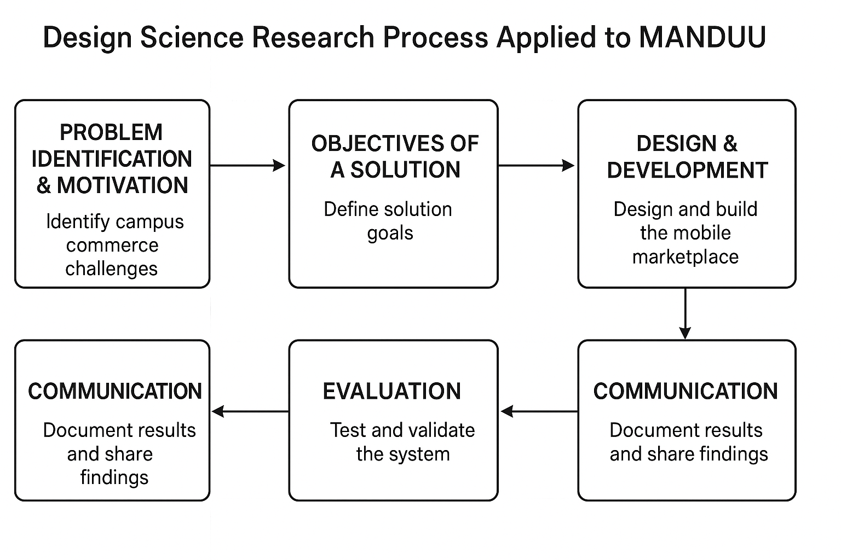
Finally, the communication stage documents the design process, findings, and implications in this dissertation. Beyond academic submission, the outcomes of this research hold potential for dissemination through conference presentations, journal publications, and technical proposals for institutional adoption. This ensures that the MANDUU project contributes both to scholarly discourse on campus digital ecosystems and to practical advancements in service delivery and trust frameworks within Ghanaian universities.
Figure 3.1: Adapted DSR methodology diagram

Design Science Research (DSR) Process for the MANDUU Project
This study adopted the Design Science Research (DSR) framework to guide the development of the MANDUU mobile marketplace application. The DSR approach was considered appropriate because it emphasizes the design and evaluation of innovative artifacts that address real-world problems. Within the University of Cape Coast (UCC) campus commerce ecosystem, the challenges identified included the lack of vendor verification, the absence of a centralized platform, the prevalence of fraud risks, and congestion in printing services. A review of academic literature and an analysis of existing platforms such as Hubtel and Jiji confirmed the relevance of these challenges in the Ghanaian university context.
In response, the objectives of the MANDUU application were defined to provide a secure and campus-specific marketplace for verified vendors, support location-based service discovery, incorporate remote printing functionalities, and ensure secure payment methods and transparent vendor ratings. These objectives were grounded in established theories, including the Technology Acceptance Model (TAM) and the Digital Trust Framework, to strengthen their relevance and applicability.
The design and development phase focused on conceptualizing the system architecture in line with user-centred design principles and software engineering best practices. The architecture incorporated modules for vendor verification, geofencing for location-based filtering, cloud-based printing, and integration of multiple payment gateways, including MTN Momo, Telecel Cash, AirtelTigo Cash, Visa and debit card, and bank transfers. Although live deployment was not conducted, workflows and specifications were validated through comparative analysis with similar systems and supported by insights from literature.
A functional prototype was then developed using .NET MAUI to ensure cross-platform compatibility. Simulated scenarios demonstrated the application’s ability to support tasks such as locating a nearby verified vendor, uploading and paying for documents through mobile money, and receiving notifications when orders were ready for collection. These demonstrations confirmed the practical feasibility of the proposed solution.
Evaluation of the system relied on technical validation rather than full-scale field testing. This involved functional testing of modules, verification of secure data transmission through SSL encryption, and a usability review based on System Usability Scale benchmarks. A comparative gap analysis was also carried out to highlight how the MANDUU application overcomes the limitations of existing marketplace platforms.
The outcomes of this research have been compiled in this dissertation for academic dissemination, with potential to inform future scholarly publications. The results also provide a proof-of-concept that may guide the University of Cape Coast’s IT Department in considering further development and full-scale implementation of the MANDUU system.

Research Approach

Overview of Approach
The research adopts a design science research methodology supported by both qualitative and quantitative elements. This approach is chosen because the project aims to both design and evaluate a functional prototype of the MANDUU mobile platform for campus-specific digital commerce. The methodology ensures that the solution is not only technically feasible but also contextually relevant to the University of Cape Coast (UCC) environment. The qualitative aspect focuses on document analysis and scenario evaluation, while the quantitative aspect captures technical performance metrics during prototype testing.

Literature-Driven Requirement Gathering
Instead of conducting primary surveys or interviews, the study relies on secondary data from peer-reviewed journals, conference papers, and case studies of existing digital commerce systems. Platforms such as Hubtel, Jiji, and Jumia Campus were examined to extract functional and non-functional requirements relevant to a university setting.
This analysis highlighted key gaps in existing solutions, such as the lack of vendor verification tied to campus communities, absence of geo-fenced service listings, and non-integration of academic service features. These findings directly informed the feature set of the MANDUU prototype, ensuring that it addresses context-specific challenges.

Qualitative Document Analysis
To better understand trust, usability, and adoption barriers in informal campus markets, the research conducted a systematic review of:
- Academic studies on mobile commerce adoption in Ghana and Sub-Saharan Africa.
- Reports on informal vendor networks within universities.
- User experience literature focusing on location-based and verification-based systems.
This qualitative evidence provided insights into student purchasing behaviours, security perceptions, and factors influencing platform adoption, which shaped the app’s design principles.

Scenario-Based Evaluation
Due to time and resource constraints, live user testing was not carried out. Instead, the research employed scenario-based evaluation, in which realistic usage cases were developed to simulate student and vendor interactions with the platform.
Examples of scenarios include:
- A first-year student searching for a verified printing service within 100 meters of their dormitory.
- A vendor receiving an in-app notification for a remote print job request.
- A student making a secure mobile payment to a verified service provider and leaving a review.
These scenarios allowed assessment of system usability, feature effectiveness, and workflow efficiency without deploying the platform to a live audience.

Quantitative Technical Performance Testing
The quantitative strand is implemented through the structured questionnaire administered to both students and vendors.
Students (n = 131): Responses are gathered on service usage patterns, trust factors, adoption likelihood, and feature preferences. Data will allow measurement of trends such as the proportion of students experiencing fraud, average waiting times at service points, and the percentage likely to adopt MANDUU.
Vendors (n = 77): Responses capture service categories, digital adoption readiness, and interest in listing services on MANUU.
Collected data will be coded and analysed statistically using SPSS or Excel, focusing on:
- Descriptive statistics (frequency distributions, percentages, means).
- Comparative analysis (e.g., male vs female adoption intentions, on-campus vs off-campus service usage).
- Correlation analysis (e.g., relationship between vendor verification and student trust).
This approach provides measurable evidence of the demand for MANDUU and the potential for adoption across different campus groups.

Ethical Considerations
Although no personal student or vendor data was collected, ethical software design principles were applied. The system’s architecture ensures compliance with Ghana’s Data Protection Act (2012) through:
- End-to-end encryption of all payment transactions.
- Secure vendor verification processes to prevent impersonation.
- Avoidance of unnecessary data collection to minimize privacy risks.
These considerations ensure that the platform, if deployed, would operate responsibly within both legal and institutional frameworks.
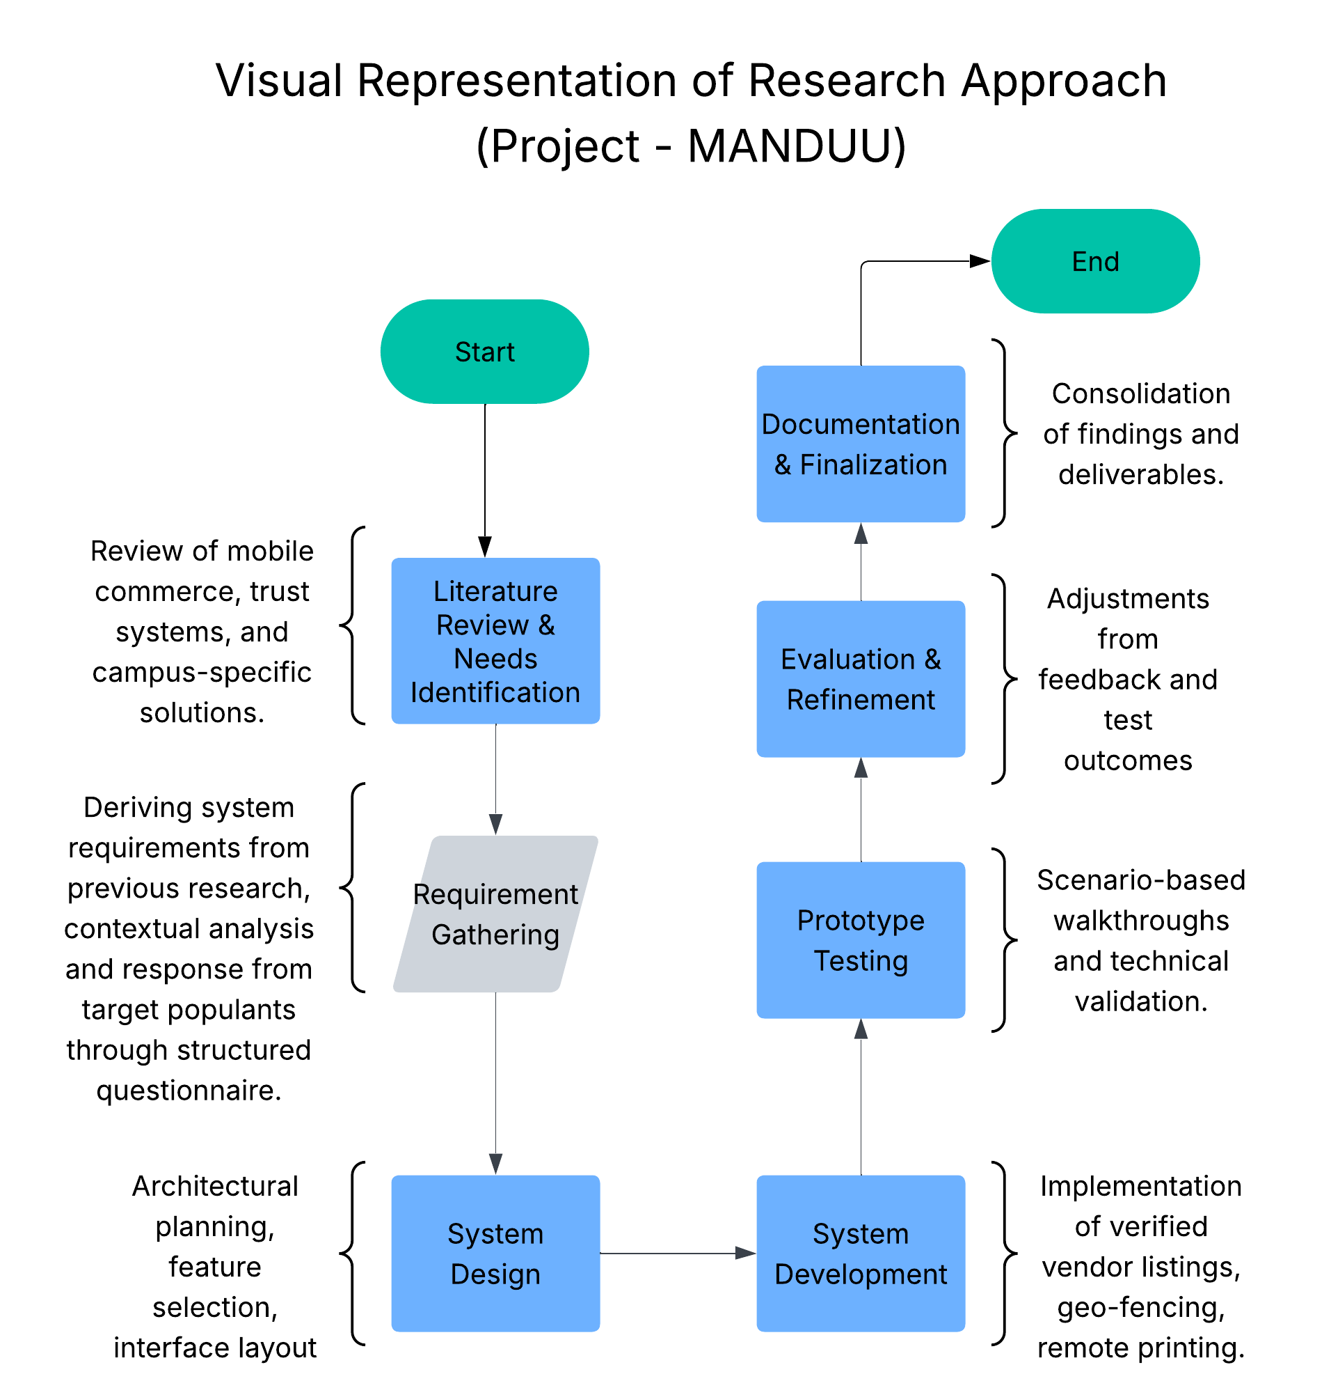
Figure 3.2 Visual representation of research approach
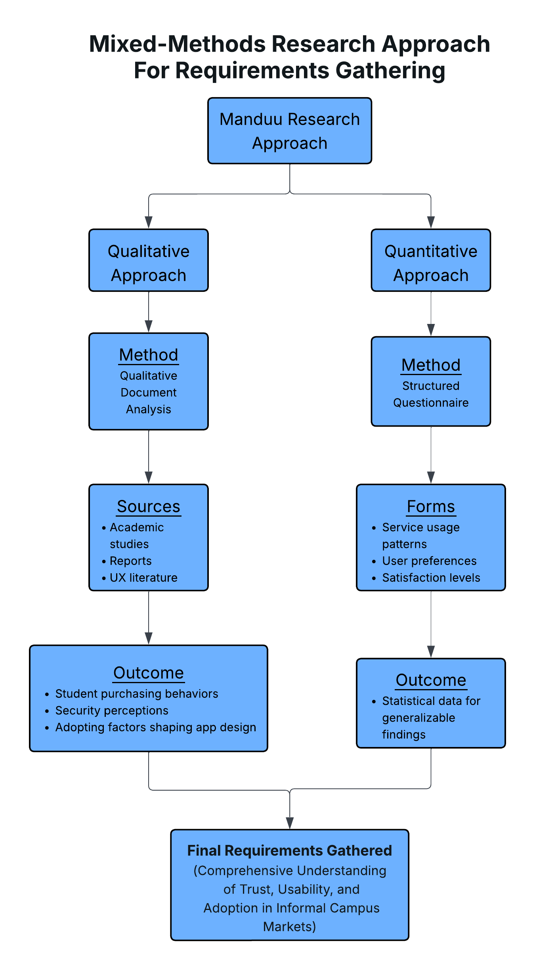
Figure 3.3 Visual representation of research approach

Study Area and Population

Study Area
The study area is the University of Cape Coast (UCC), Ghana. The university environment is well-suited to this research because it contains a dense, semi-closed community with predictable mobility patterns and a vibrant informal service economy. For the MANDUU platform, the relevant campus zones include:
Student residential areas: Halls and hostels where demand for everyday services (e.g., printing, laundry, grooming) concentrates.
Academic precincts: Lecture theatres, faculty blocks, libraries, and study spaces where time-sensitive service needs arise (e.g., urgent printing/photocopying).
Service hubs: Designated vendor corridors/shops (e.g., print and stationery clusters), ICT centres, and administrative offices.
Transit corridors & common areas: Walkways and nodes where location-based discovery is most useful (e.g., “find the nearest verified photocopy shop within 200m”).
The campus provides a bounded, geo-fencible environment that aligns naturally with MANDUU’s location-based service discovery and vendor verification goals.

Target Population
The research focuses on two primary stakeholder groups that directly interact through the proposed platform:
- Students (Primary Users)
- Undergraduate and postgraduate students who require reliable access to verified, nearby services.
- Typical needs include printing/photocopying, document binding/lamination, stationery, IT/device support, laundry, tailoring/mending, and grooming (barbering/hair services).
- Relevance: Students are the main demand-side users; their perceptions of trust, convenience, and usability determine adoption.
- Campus Vendors (Secondary Users)
- Small, mostly informal businesses operating on or immediately around campus (e.g., print/photocopy shops, stationery suppliers, device repair/IT support, laundry services, tailoring, grooming).
- Relevance: Vendors constitute the supply-side users; their onboarding, verification, listing quality, and responsiveness shape overall platform value.

Inclusion & Exclusion (Conceptual)
The inclusion and exclusion criteria define the scope of the study population to ensure that the research targets the intended users and stakeholders of the MADUU platform. This approach guarantees that data collection, analysis, and recommendations remain relevant to the campus ecosystem of the University of Cape Coast (UCC).
Inclusion Criteria
Students: All currently enrolled UCC students at any academic level (undergraduate, postgraduate, or professional programmes) who actively use, or have expressed interest in using, campus-based goods and services. This includes both residents in on-campus halls of residence and students commuting from outside campus (hostels).
Vendors:
- Student-owned service providers operating within the physical boundaries of UCC.
- Non-student vendors with an established physical presence within the campus, whose primary clientele are UCC students.
- Vendors willing to participate in a verification process, which may include providing valid identification, institutional permits, or other relevant documentation.

Exclusion Criteria
- Vendors or enterprises that operate exclusively off-campus and do not directly serve UCC students.
- Services unrelated to academic, residential, or campus community life (e.g., unrelated commercial or industrial services).
- Service categories explicitly disallowed by UCC’s institutional policies or regulations (e.g., prohibited goods, unsafe services, or activities that conflict with university values).

Justification for Site and Population
The University of Cape Coast (UCC) was strategically selected as the study site due to its distinctive campus layout, service ecosystem, and commercial culture, all of which align closely with the objectives of the MANDUU platform. The following factors justify this choice:
Campus Specificity: UCC possesses a relatively compact yet diverse campus geography, with academic blocks, residential halls, and service hubs located within close proximity to one another. This spatial arrangement creates an environment well-suited to the implementation of geo-fenced service listings and location-based recommendations, both of which are core features of the MANDUU system. Furthermore, the high student density in key areas increases the effectiveness of verification-based trust mechanisms, as vendors and customers operate in a shared and familiar physical space.
Informal Commerce Context: A substantial portion of campus commerce at UCC is driven by small-scale and often informal vendors, ranging from print shops and laundry services to personal grooming providers. While these services are integral to daily student life, their lack of formal visibility creates a trust and discovery gap. Students often rely on word-of-mouth referrals or trial-and-error experiences, leading to inefficiencies, inconsistent service quality, and increased vulnerability to fraudulent activities. The MANDUU platform directly addresses these issues by providing a centralized, verified, and easily navigable digital marketplace tailored to the campus context.
Scalability and Transferability of Insights: Although this research is focused on UCC, the insights and outcome, both from user data and the developed prototype, have broader applicability across Ghanaian higher education institutions. Many other campuses share similar patterns of informal service provision, student demographics, and spatial organization. By first piloting MANDUU in a controlled and well-understood environment like UCC, the study can generate validated design principles, implementation strategies, and operational data that can inform cross-campus rollouts in the future.

Sampling Technique
To ensure representativeness and capture diverse perspectives of the MANDUU study, a stratified random sampling approach was adopted. The target population consists of two strata:
Students (end-users of services).
Campus vendors (service providers).
Within each stratum, participants were selected to reflect variation in age, gender, level of study (for students), and type of service offered (for vendors). This stratification helps address the heterogeneity of campus commerce and ensures that no subgroup is underrepresented (Creswell & Plano Clark, 2018).
Students: A random sample of students was drawn across different levels (L100–L400, postgraduate), residence status (on-campus/off-campus), and service usage frequency. This ensured that the responses captured the experiences of both frequent and occasional users of campus services.
Vendors: Purposive sampling was applied to vendors, since their population is relatively smaller and concentrated. Vendors were selected across service categories such as printing, stationery, grooming, laundry, tailoring, and IT/device repair. This allowed the study to represent the range of services relevant to the MANDUU prototype.
The sample size was guided by Yamane’s (1967) formula for determining sample size with a finite population, ensuring statistical adequacy while remaining feasible for data collection. The final sample comprised 131 students and 77 vendors, a distribution sufficient to capture both breadth and depth of insights.
This combination of stratified random sampling (for students) and purposive sampling (for vendors) was considered most appropriate. It balances rigor with practicality: students are numerous and require randomization for representativeness, whereas vendors are fewer and better captured through targeted selection.

Data Collection Methods
The success of this research depends on obtaining accurate and relevant data that reflects the needs and perceptions of both students and vendors at the University of Cape Coast (UCC). This study will rely on two main sources of data: primary data and secondary data.

Primary Data Collection
Primary data will be obtained directly from students and vendors using structured questionnaires.
The students’ questionnaire, which focused on quantitative data, was administered to both undergraduate and postgraduate students. It was designed to capture key information such as the frequency of campus service usage, levels of satisfaction with existing vendors, and challenges encountered including fraud, delays, and lack of trust. It also explored students’ willingness to adopt a campus-specific digital platform like MANDUU. To ensure that responses were structured and measurable, the questionnaire employed a mix of multiple-choice questions, Likert scales, and yes/no options.
The vendors’ questionnaire, which focused on quantitative data, was distributed to campus vendors such as printing shops, laundry services, device repairers, and grooming businesses. It collected information on their current methods of reaching students, the challenges they face in areas such as marketing, payments, and trust, as well as their willingness to list services on the MANDUU platform. It also explored the specific features or support vendors would require to adopt the system. The questionnaire was similarly structured to ensure easy tabulation and statistical analysis.

Justification of Methods
Efficiency: Structured questionnaires are less time-consuming and can reach a wide range of respondents quickly.
Reliability: Standardized response formats ensure that data collected is easy to analyse and compare.
Relevance: Questionnaires directly capture user and vendor needs, while secondary sources enrich findings with broader theoretical and contextual insights.

Data Collection Instruments
The choice of data collection instruments is critical in ensuring that the information gathered for this study is reliable, valid, and aligned with the research objectives. For the MANDUU study, two primary instruments will be employed: structured questionnaires for students and structured questionnaires for vendors. These instruments were chosen for their efficiency in capturing standardized data across a large sample and their ability to generate both descriptive and inferential insights.

Students Questionnaire
The student questionnaire is designed to capture the perspectives of MANDUU’s primary end-users: students of the University of Cape Coast. It is divided into five sections for clarity and alignment with the study’s objectives:
Section A: Demographics
- Captures gender, age, level of study, and residence status (on-campus vs. off-campus).
- This information supports segmentation and cross-analysis of results.
Section B: Service Use & Roles
- Identifies the types of campus services students frequently use (e.g., printing, laundry, IT/device repair, grooming).
- Measures frequency of service usage (daily, weekly, monthly, rarely).
- Assesses whether students act only as service consumers or also as vendors.
Section C: Digital Platforms & Awareness
- Explores students’ prior exposure to digital platforms such as Hubtel, Tonaton, or Bolt.
- Evaluates satisfaction with these platforms and highlights perceived gaps relevant to MANDUU.
Section D: Trust, Safety & Discovery
- Uses Likert-scale questions (1 = Not Important, 5 = Very Important) to measure the importance of trust, verification, price, proximity, and service quality when selecting campus vendors.
- Includes a question on challenges encountered with current vendors (fraud, overpricing, poor quality).
Section E: App Concept (MANDUU)
- Introduces the MANDUU app prototype concept and measures willingness to adopt it.
- Allows students to rank useful features such as:
- Verified vendor profiles
- Location-based service discovery
- Service categories
- Price transparency
- Captures possible concerns (privacy, adoption, listing fees).
Section F: Final Notes
An open-ended space for students to suggest improvements that could enhance MANDUU’s usability and adoption.

Vendors Questionnaire
The vendor questionnaire is tailored to secondary users: campus service providers. It is structured into three sections:
Section A: Current Business Practices
- Identifies the type of service offered (printing, laundry, grooming, device repair, etc.).
- Captures current methods of reaching students (word of mouth, posters, social media, WhatsApp groups).
- Probes challenges vendors face in marketing, payments, and building student trust.
Section B: Reactions to MANDUU
- Introduces the MANDUU concept as a campus-specific app.
- Measures vendor interest in joining the platform using a 5-point scale (Not Interested → Very Interested).
- Identifies motivating factors such as access to more customers, easy payments, and increased credibility.
- Asks vendors what type of support they would need (training, marketing, digital payment setup).
Section C: Final Input
- Gathers vendors’ concerns (fees, adoption rates, verification process).
- Provides an open-ended section for suggestions to improve the platform’s relevance to their businesses.

Instrument Design Consideration
Clarity & Simplicity: Questions are written in plain, accessible language to suit a diverse respondent base.
Structure: Closed-ended questions dominate, ensuring that responses can be statistically analysed, while selected open-ended questions provide depth.
Relevance: Each question aligns with one or more research objectives, ensuring that collected data directly informs the study.
Pretesting: Though time constraints limit extensive pilot testing, questionnaires will undergo expert review (by supervisor and research team) to ensure alignment and accuracy.

Data Analysis Plan
The purpose of the data analysis plan is to outline how responses collected through the questionnaires will be systematically processed, organized, and interpreted to address the research objectives. Given that the study adopts a mixed-methods approach, the analysis will combine quantitative statistical techniques and qualitative thematic analysis to ensure both measurable insights and contextual understanding.

Quantitative Data Analysis
Quantitative data will be derived primarily from structured, closed-ended questions in the student and vendor questionnaires (e.g., service usage frequency, Likert-scale ratings of trust factors, satisfaction levels, adoption likelihood). The analysis will follow these steps:
Data Cleaning and Coding: Responses will be checked for missing or inconsistent entries. Categorical variables (e.g., gender, level of study, vendor type) will be coded numerically for statistical processing.
Descriptive Statistics: Frequencies and percentages will be calculated to summarize demographic information (e.g., age distribution, service usage frequency). Measures of central tendency (mean, median, mode) will be used to summarize Likert-scale responses (e.g., average importance of trust in vendor selection).
Visualization: Graphs, bar charts, and pie charts will be employed to visually communicate key findings such as:
- Distribution of service usage among students.
- Vendor challenges ranked by frequency.
- Importance ratings for trust, price, and proximity.

Qualitative Data Analysis
Qualitative data will be drawn from open-ended responses in the questionnaires (e.g., “What concerns might prevent you from using the app?”, “What improvements would you suggest?”). These will be analysed using thematic analysis:
Data Familiarization: Responses will be transcribed into a structured dataset and reviewed repeatedly for patterns.
Initial Coding: Responses will be coded into smaller segments (e.g., “privacy concerns,” “cost issues,” “need for marketing support”).
Theme Development: Codes will be grouped into broader themes such as Trust & Safety, Adoption Barriers, and Platform Usability.
Interpretation: Themes will be interpreted in relation to the research questions and compared with findings from related literature.

Integration of Qualitative and Qualitative Findings
The mixed-methods integration will take the form of triangulation, where numerical results are compared with qualitative insights to generate a comprehensive understanding. For instance:
- If 70% of students rate vendor verification as "very important" (quantitative), qualitative comments may provide deeper reasoning (e.g., past experiences with fraud).
- Vendor challenges reported numerically (e.g., low visibility = 60%) will be complemented by qualitative suggestions (e.g., "MANDUU should help us advertise to first-year students").
This integration ensures that the breadth of numerical trends and the depth of lived experiences are captured together.

Tools For Analysis
- Microsoft Excel and Google Sheets will assist with charts and basic data visualization.
- Manual thematic analysis (using coding matrices) will be applied to qualitative responses.

Ethical Considerations
Ethics forms a central pillar of any academic research, particularly when human participants are involved. Since this study engages both students and campus vendors at the University of Cape Coast (UCC), ethical safeguards are necessary to protect participants’ rights, ensure data confidentiality, and maintain the integrity of the research process. This section outlines the ethical protocols observed in the conduct of this research.
Informed Consent: Before participation, all respondents were clearly informed about the purpose of the study, the voluntary nature of their participation, and how their responses would be used. Participation proceeded only after explicit consent was obtained. This aligns with the ethical principle of autonomy, which emphasizes respect for individuals’ right to make informed choices about their involvement.
Voluntary Participation and Right to Withdraw: Participants were under no obligation to take part in the study and could withdraw at any stage without penalty. No inducements or coercion were employed. This ensures fairness and compliance with the Belmont Report’s principle of respect for people.
Anonymity and Confidentiality: Respondent anonymity was guaranteed throughout the data collection process. Questionnaires did not require names or personal identifiers beyond basic demographic information (e.g., age, gender, level of study). In cases where vendors disclosed business names, these were coded to prevent traceability in the published results. All responses were stored securely and used solely for research purposes.
Data Protection and Security: To maintain data integrity and protect sensitive information, digital survey responses were stored in password-protected files accessible only to the research team. Printed questionnaires (if any) were kept in locked storage. All data will be destroyed after the mandatory retention period in accordance with UCC’s academic policies and Ghana’s Data Protection Act, 2012 (Act 843).
Minimizing Risk and Harm: This study posed minimal to no physical or psychological risks to participants. Questions were carefully designed to avoid sensitive or distressing content. In the unlikely event of discomfort, participants were free to skip questions or terminate participation altogether.
Transparency and Feedback: Participants were informed that aggregate findings (not individual responses) may be shared with the University community. Vendors and students were assured that their input would directly inform the design of a prototype aimed at improving campus commerce. This feedback mechanism fosters trust and accountability between researchers and participants.
Equity and Inclusion: The study made deliberate efforts to include a diverse pool of respondents across gender, level of study, and type of vendor. By ensuring balanced participation, the research avoids bias and enhances representativeness of the findings. Special care was taken to ensure that participation was accessible to vendors with limited literacy or digital literacy, by allowing oral clarifications during questionnaire administration.

CHAPTER FOUR: DATA REPRESENTATION AND ANALYSIS

Introduction
This chapter presents, and interprets information collected among vendors and students in the University of Cape Coast (UCC). The objective is to build knowledge regarding prevailing access challenges with existing services, operations of vendors, and perceived usefulness of a safe, location-based mobile marketplace such as the proposed MANDUU.
The analysis follows a structured path, beginning with descriptive statistics of the population sample to provide context (demographics, study/work roles, and service use patterns). Then, it probes students' and vendors' experience with existing approaches to service access, i.e., trust, convenience, and ease of access problems. Lastly, the chapter addresses familiarity with digital platforms, levels of satisfaction with them, and primary issues encountered in campus commerce.
Apart from current practices, the findings also indicate impressions of the MANDUU prototype as a solution. Students' and vendors' opinions regarding the suggested features of the platform including, vendor authentication, geo-fenced listings, remote printing integration, and in-app communication, are recorded. These opinions are further presented in contexts of current literature regarding mobile commerce, campus-specific service ecosystems, and digital trust frameworks.
The chapter is wrapped up by synthesizing the way collected. data supports or disproves the assumptions based on earlier chapters, specifically the problem statement and research questions. In doing so, it provides an evidence-based basis for determining the relevance of MANDUU and broader implications for digital campus commerce in Ghanaian universities.

Demographic Characteristics of Respondents
It is necessary to know the demographic makeup of the respondents in order to contextualize the findings of this study. Since MANDUU is designed for two main user groups, students (both as consumers and providers of the service) and vendors on campus (as providers of the service), the demographics are categorized here based on student respondents and vendor respondents.

Students Respondents
131 students responded to the survey, which presented a representative demographic profile in gender, age, and study level. Responses were approximately split between male and female students to ensure both genders' use of services was adequately represented. The majority of the respondents were aged between 20 and 29 years, reflective of the broader undergraduate population at UCC, while an added diversity in campus service use was brought by a smaller sub-group of older postgraduate estudents.
Members were sampled from the three levels of study (100 to 400 and postgraduate) to guarantee perspectives from both first-year as well as final-year students. Surprisingly, Level 200 and Level 300 students made up the majority percentage, since they played active roles in campus life.
Both on-campus and off-campus students took part, of which a majority were off-campus residents (hostel residents). This is an important distinction since service
accessibility and dependence might vary considerably between the two groups.
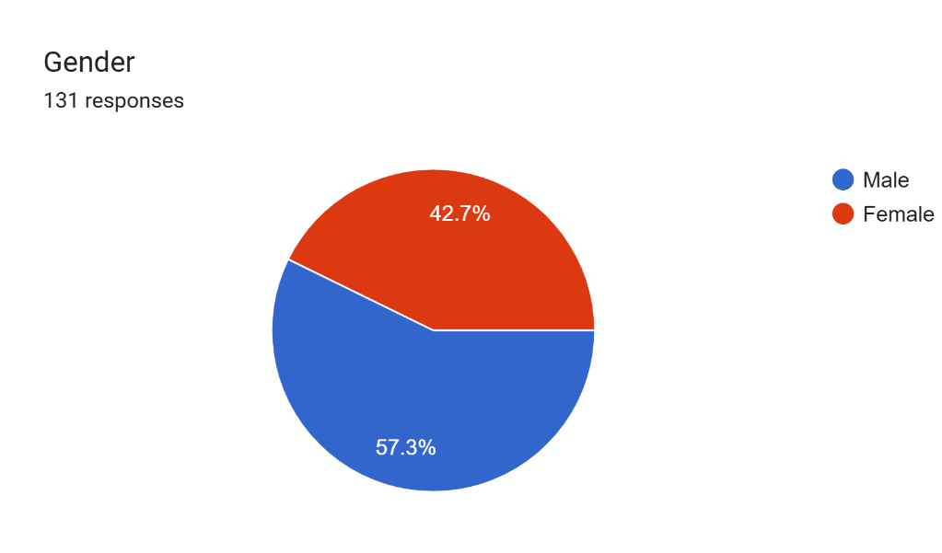
Figure 4.1: Pie chart of males and females who partook in the survey (from student CSV)
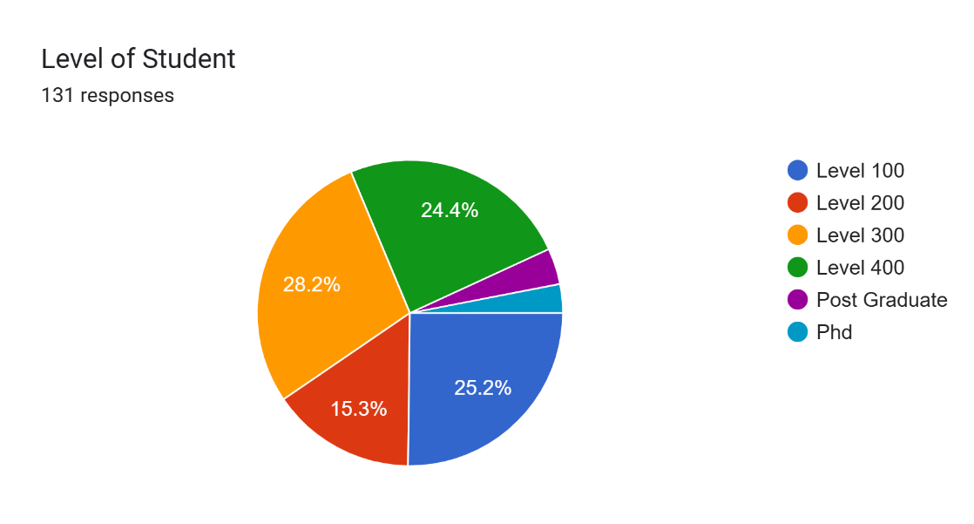
Figure 4.2: Bar chart of age range of respondents (from student CSV)
Figure 4.3: Pie chart of respondents’ levels of study (from student CSV)
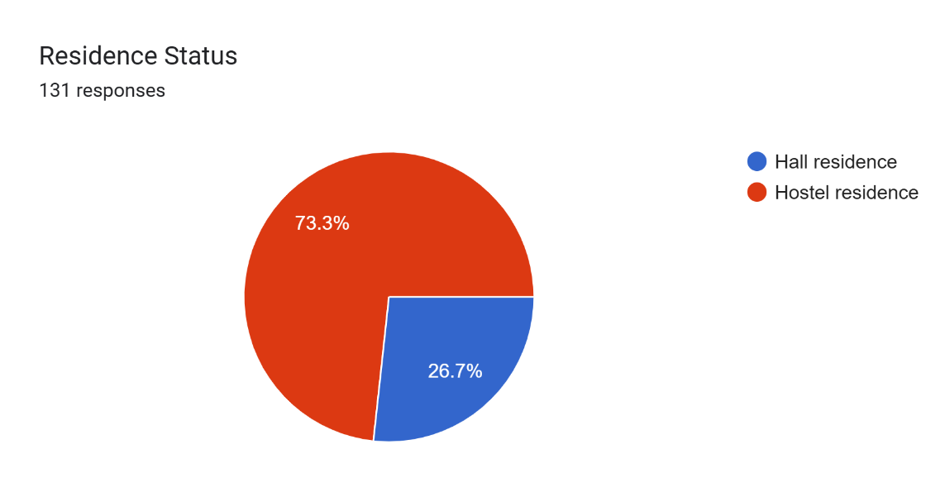
Figure 4.4: Pie chart of respondents’ residence status (from student CSV)

Vendors Respondents
Vendors constitute the second main group of MANDUU stakeholders. A total of 77 vendors took part and had the following characteristics. Vendor respondents served a variety of services, ranging from printing/photocopying and stationery selling to device repairing, laundry, food, and haircuts. This variety is indicative of the informal but important service economy of UCC's campus.
The data indicated a mix of student businesses (entrepreneurial efforts by students at UCC) and off-campus merchants with a physical presence within school. Both are central to MANDUU's conception, which aims to interface students with trusted and legitimate service providers.
The data revealed a mix of student-run businesses (entrepreneurial ventures by UCC students) and external vendors with a physical presence on campus. Both groups are critical to MANDUU’s design, which aims to bridge students with verified and trusted service providers.
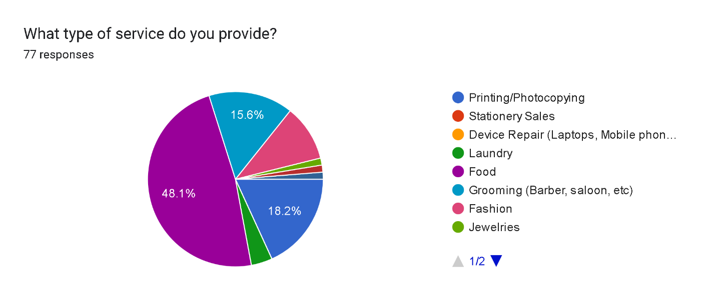
Figure 4.5: Pie chart of services offered by vendor respondents (from vendor CSV)

Service Use Patterns – Students
Understanding how students currently use campus services is crucial to evaluating the potential impact of MANDUU. The questionnaire explored the types of services students rely on, their frequency of usage, and the challenges they face with discovery and trust.

Types of Services Accessed
Students were asked to indicate the campus-based services used in the previous month, and results indicated a broad spectrum of service need with some services bordering on universality. Printing/photocopying and eating were most utilized, reflecting the academic requirements and nutritional demands of students within the university environment. Buying stationery and device/IT repairs were also universally reported, particularly during examination periods when academic pressure is highest. Also prominent were services like laundry, tailoring, buying clothes, and grooming (barbering, salons, and make-up), reflecting the high demand for convenience-based personal services among students. Students were queried on which campus-related services they had utilized in the last month, and the findings reflected a wide range of service demand with some services approximating universality. Printing/photocopying and meals seemed the most used, reflecting both the learning needs and the hunger of students in the university environment. Stationery purchases and device/IT repair were also broadly mentioned. Other personal services such as laundry, tailoring, clothing shopping, and grooming (barbering, salons, make-up) also featured highly, reflecting the strong demand from students for convenience-oriented personal services.
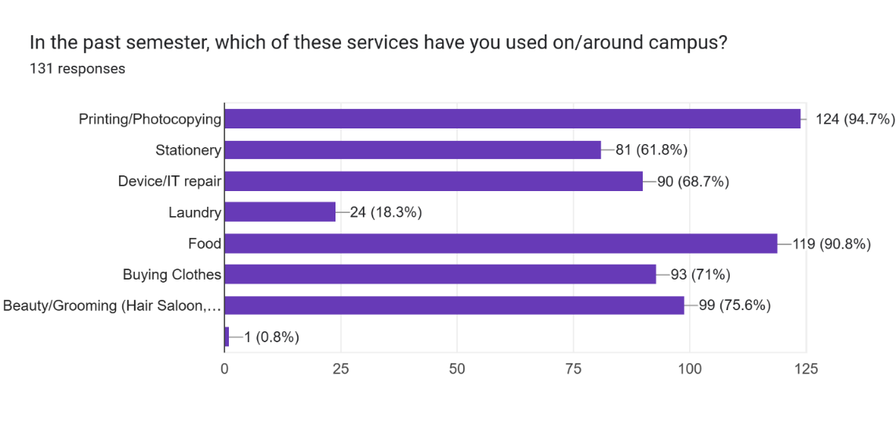
Figure 4.6: Bar chart of service categories used by students (from student CSV).

Frequency of Service Use
The same survey also highlighted the frequency of interaction between students and vendors, as seen through varying patterns of service utilization. A significant proportion of students reported weekly utilization of campus facilities, particularly printing, food, stationery, and grooming, which are integral to student daily life. Greater frequencies were observed among students residing in halls, who utilize printing centres, laundry, and instant grooming facilities extensively. On the other hand, monthly or sporadic usage was perceived for services such as repair of devices and tailoring, required only occasionally. This profile points to the need for MANDUU to enable high-volume, frequent-use services such as printing as well as required though low-frequency services such as repair of devices.
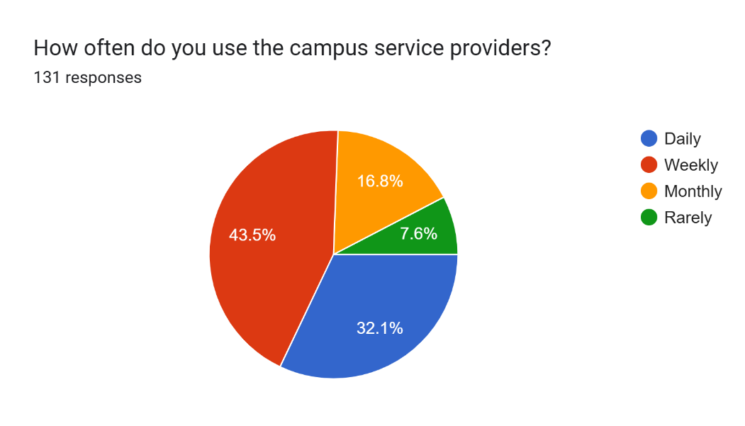
Figure 4.7: Frequency of service usage (pie chart or bar chart from student CSV).

Student Vendors (Entrepreneurial Engagement)
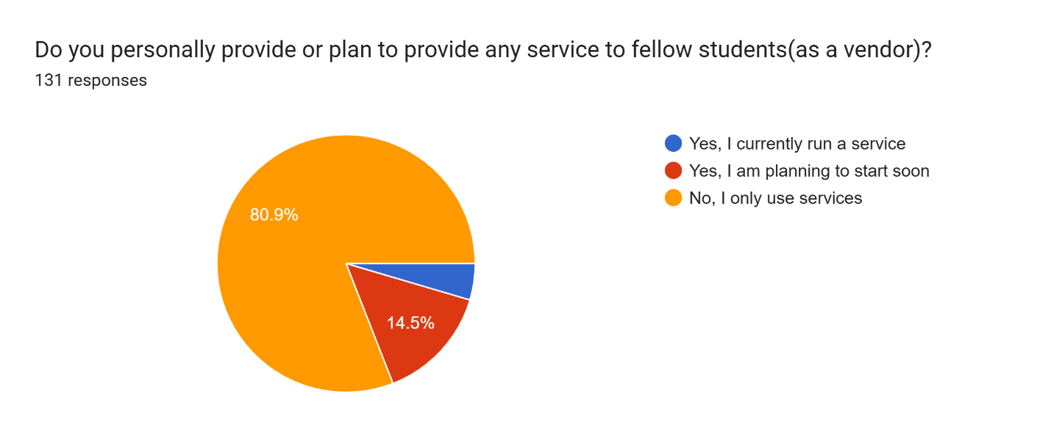
Interestingly, a portion of students indicated that they are themselves service providers or plan to become vendors on campus. This trend validates the dual-role design of MANDUU: both as a discovery platform for service seekers and as a growth tool for student entrepreneurs.
Figure 4.8: Proportion of students who act as vendors or plan to start (bar chart).

Challenge in Current Service Use
Students identified several challenges when accessing campus services, many of which align with the problem statement outlined in Chapter 1. Common issues included long queues and waiting times at print centres, difficulty locating trustworthy vendors, particularly for new students, and inconsistency in service quality in areas such as tailoring, grooming, and laundry. Additionally, concerns about overpricing or hidden charges often led to mistrust between students and vendors. Another notable challenge was the lack of visibility for student entrepreneurs, who primarily relied on word-of-mouth to market their services. These findings reinforce the need for MANDUU’s core features, such as vendor verification, geo-tagging, and transparent listings, to address these systemic gaps.
Students identified several challenges when accessing campus services, many of which align with the problem statement outlined in Chapter 1. Common issues included long queues and waiting times at print centres, difficulty locating trustworthy vendors (particularly for new students), and inconsistency in service quality in areas such as tailoring, grooming, and laundry. Additionally, concerns about overpricing or hidden charges often led to mistrust between students and vendors. Another notable challenge was the lack of visibility for student entrepreneurs, who primarily relied on word-of-mouth to market their services. These findings reinforce the need for MANDUU’s core features, such as vendor verification, geo-tagging, and transparent listings, to address these systemic gaps.

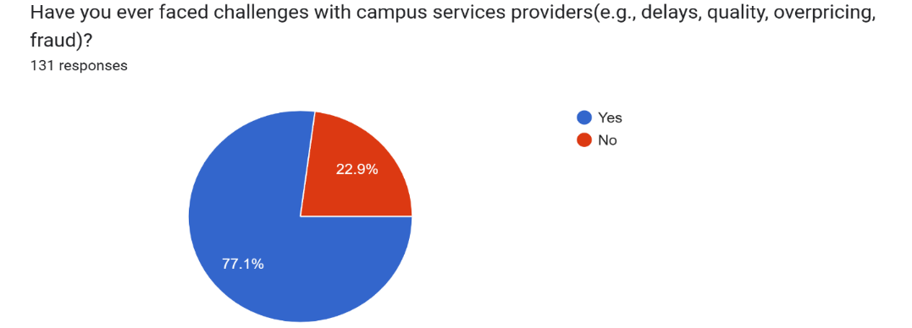
Figure 4.9: Percentage of students reporting challenges with campus vendors (pie chart and bar chart from student CSV).

Summary (Service Use Patterns – Students)
The usage patterns of services by students reveal that demand spans across a wide array of categories but is firmly led by grooming, stationery, and printing services. Such services are consistently and regularly used, which emphasizes the utility of a digital marketplace in the campus setting. Such issues of trust, accessibility, and efficiency still remain to be addressed within the informal system that exists. Simultaneously, the active participation of student-vendors identifies an entrepreneurial niche which MANDUU can unlock through the provision of a platform that legitimates and magnifies such operations.

Vendor Challenges and Practice
While students represent the primary users of MANDUU, vendors form the backbone of the ecosystem. Understanding their practices, pain points, and openness to adopting a digital marketplace is crucial for ensuring successful platform design and adoption.

Types of Services and Provided
Surveyed campus vendors stated they primarily are located in a limited number of core categories of services. The leading category was printing and photocopying services, as these were considered essential to students' academic needs. Food services were closely followed because of their essentiality in providing daily nutritional needs. Sales of stationery were also common, typically bundled with printing shops to create bundled service outlets. Device repair, like phones, laptops, and other electronics, was another critical category, which dealt with typical technical problems students face. Laundry services were also offered for both on-campus and off-campus students who prefer convenience, while grooming services, e.g., barbering, salons, and make-up, rounded up the necessary vendor
offerings, highlighting the array of student lifestyle needs on campus.
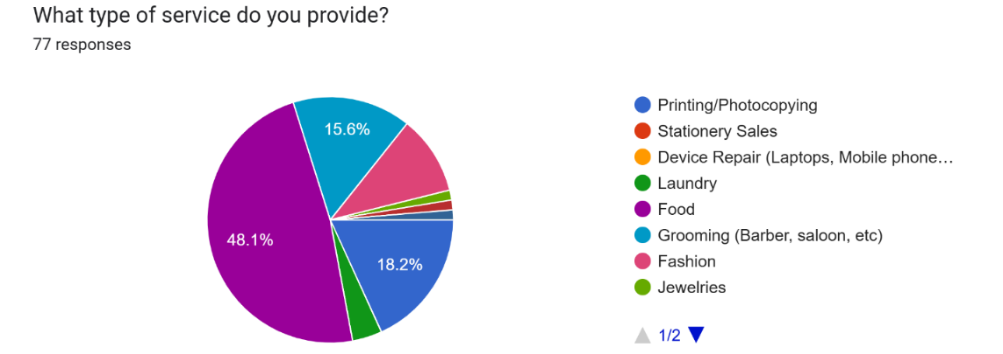
Figure 4.10: Distribution of vendor service categories (bar chart from vendor CSV).

Current Marketing and Outreach Practices
All the vendors surveyed indicated that they relied heavily on informal marketing channels to reach students. Word-of-mouth remains the most common approach, especially for long-established vendors with frequent customers. Flyers and posters are also used, particularly by print shops needing visibility in high-traffic campus locations. Social media platforms such as WhatsApp, Instagram, Facebook, and TikTok are widely popular, especially among student businesses employing peer networks for advertising their products. Additionally, certain vendors avail themselves of direct message and call for order placement after confirmation. Only a limited number of vendors employed structured digital platforms like Hubtel, largely due to the very high charges and narrow applicability in the campus context. This highlights a significant digital adoption gap, one which MANDUU wants to fill by becoming the marketplace of choice for students with specific appeal to the campus environment's unique demands.

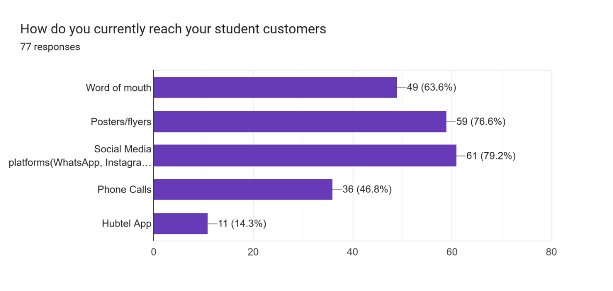
Figure 4.11: Marketing channels used by vendors (stacked bar chart).

Challenges Vendors Face
Most of the vendors utilize informal networks to contact students, and word of mouth is still the most common way, especially for long-standing vendors with established clienteles. Flyers and posters are still visible but are used primarily by print shops to grab pedestrians in high-traffic locations on campus. Social media platforms like WhatsApp, Instagram, Facebook, and TikTok are becoming more popular, particularly with student entrepreneurs who make use of peer networks for promoting their services. Some vendors also make direct calls or use messaging as a means of managing orders and inquiries. Fewer vendors are, however, utilizing organized digital platforms like Hubtel due to prohibitive charges and the lack of campus-based features. This real void in digital adoption offers a stage for MANDUU to emerge as the first-choice market place offering a trusted, low-cost, and student-oriented solution tailored to the campus environment
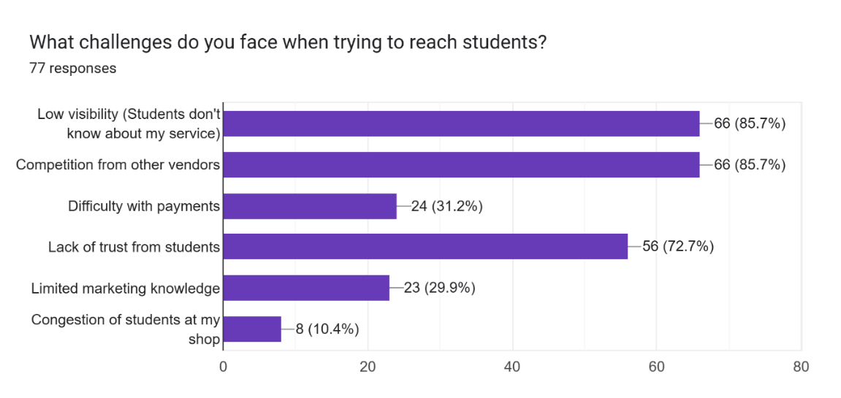
Figure 4.12: Reported challenges by vendors (percentage breakdown).

Vendor Receptiveness to MANDUU
When asked about potential involvement in a campus-specific platform like MANDUU, vendors generated nearly uniformly positive responses. Many stated that they were either "interested" or "very interested" in getting involved, reflecting robust demand for digital transformation of the campus services ecosystem. Their main motives were centred on tangible business benefits: gaining access to a greater student client base, enjoying easy and secure ways of payment processing, achieving more visibility and credibility from certified listings, and reducing the time and effort invested in traditional advertising. These responses suggest that suppliers do not only recognize the limitations of the current informal system but find MANDUU to be a feasible route to enhanced efficiency, trust, and growth.
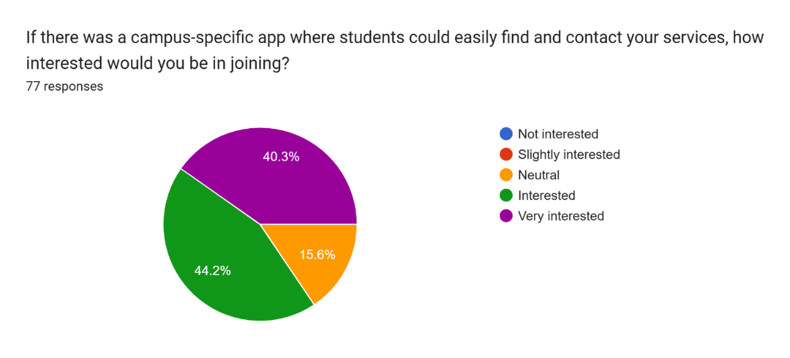
Figure 4.13: Vendor willingness to join MANDUU (pie chart).

Support Needs for Adoption
To utilize MANDUU best, vendors emphasized the necessity for gaining support services for their minimum needs that would enable them to easily integrate into the platform. Some of the aspects of support that were brought out included training on app use, such that even less technologically savvy vendors would find its operations easy to use. They also quoted the need for assistance in creating payment channels, particularly for mobile money and bank transfers, which are necessary for hassle-free digital payments. Another frequent request was for help in creating professional service profiles, like nice photos, descriptions, and easy-to-understand pricing to make it simpler and more reliable to be discovered. Finally, vendors were keen on establishing support, i.e., targeted promotion or student-focused campaigns, to further reach and participate in the university community. These findings again assert that the success of MANDUU shall not solely depend on its technical features but on capacity building and onboarding programs allowing vendors to thrive in the digital marketplace.
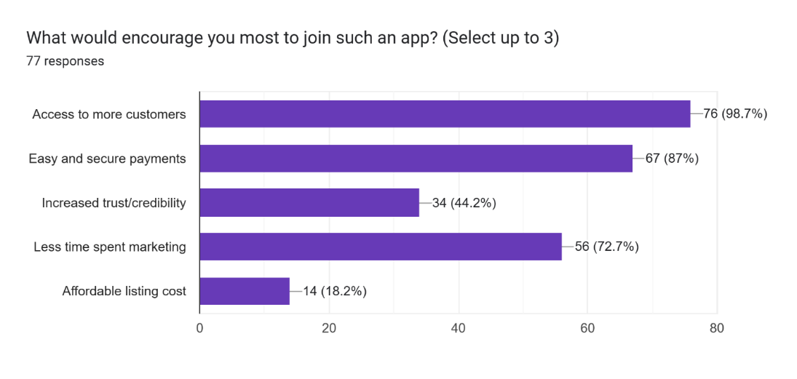
Figure 4.14: Vendor support requirements (bar chart).

Concerns About Digital Platforms
Although there was general strong support for MANDUU, vendors also had several concerns that would limit adoption if not addressed. An express concern was fear of not being adopted by students since some vendors doubted whether students would utilize the platform on a regular basis. Most vendors also raised the potential cost of listing services, mentioning that excessive fees would discourage participation, especially in the initial stages of adoption. Data privacy and security also became a top priority, with the vendors looking for assurances that their data would be protected. Finally, there was scepticism regarding the effectiveness of the verification systems, with concerns being raised about whether the platform would be capable of successfully differentiating between authentic vendors and imposter vendors.
These problems will have to be addressed via intentional trust-building strategies. Solution proposals include student adoption campaigns, reduced-rate or free trial listing periods, open data protection policies, and high-profile verification badges and review programs to reassure vendors regarding the validity of the platform. Overall, they will play a key role in fostering confidence and encouraging long-term vendor engagement.

Summary (Vendor Challenges and Practice)
The findings from surveys of vendors highlight notable observations regarding the dominant campus business climate and MANDUU's potential to fill gaps. Vendors are present only in high-demand service segments such as printing, stationery, food, laundry, grooming, and device repair; nonetheless, they always face visibility challenges as well as intense competition from the informal and dispersed manner of marketing practice. Advertising continues to rely on word of mouth, pamphlets, and rudimentary use of social networking sites, suggesting that there are no formalized digital media for campus business.
Encouragingly, there is significant interest in adopting a campus-based digital marketplace, with vendors being particularly keen on the prospects for secure mobile payments, increased visibility, and credibility via verification processes. Meanwhile, the survey identifies that vendors will require onboarding support through training, professional profile support, and rudimentary marketing support in order to be able to leverage extensively the ability of the app.
Despite such optimism, vendors remain concerned about adoption levels, the cost of listing facilities, and the effectiveness of verification and trust procedures. Such problems mean MANDU's launch strategy must incorporate proactive measures in the form of pilot exercises, free or subsidized listings, open trust-building procedures, and vendor-student outreach campaigns. Timely settlement of these problems will be crucial to securing vendor buy-in and long-term sustainability of the platform.

Trust Safety and Discovery Analysis
Trust, safety, and visibility are among the most critical factors influencing student–vendor interactions on campus. The responses from both student questionnaires and vendor questionnaires reveal significant gaps that directly informed the conceptualization of MANDUU.

Importance of Trust and Verification
When respondents were asked to rank the importance of factors that influence campus vendor choice, trust and verification rated highest as the most critical determinants, closely followed by service quality and cost. In excess of 80% of the surveyed respondents rated vendor trust and verification as "very important," noting the central role of credibility in influencing consumer decision in informal campus markets. They mentioned that they prefer interacting with vendors who are recommended by fellow students through word of mouth or visibly certified by an official verification process.
From the vendors' point of view, the trust issue was also at the forefront. Most vendors, particularly new or small-scale operators, emphasized that a credibility and visibility deficit deny them the ability to maintain customer relationships and effectively compete with their more experienced counterparts. This convergence of perspectives (students seeking greater assurance of genuineness and vendors struggling to lead trustworthiness) strongly vindicates the existence of MANDUU's verification platform, review systems, and geo-tagging features as a means of bridging the void of trust gap between student customers and service providers.
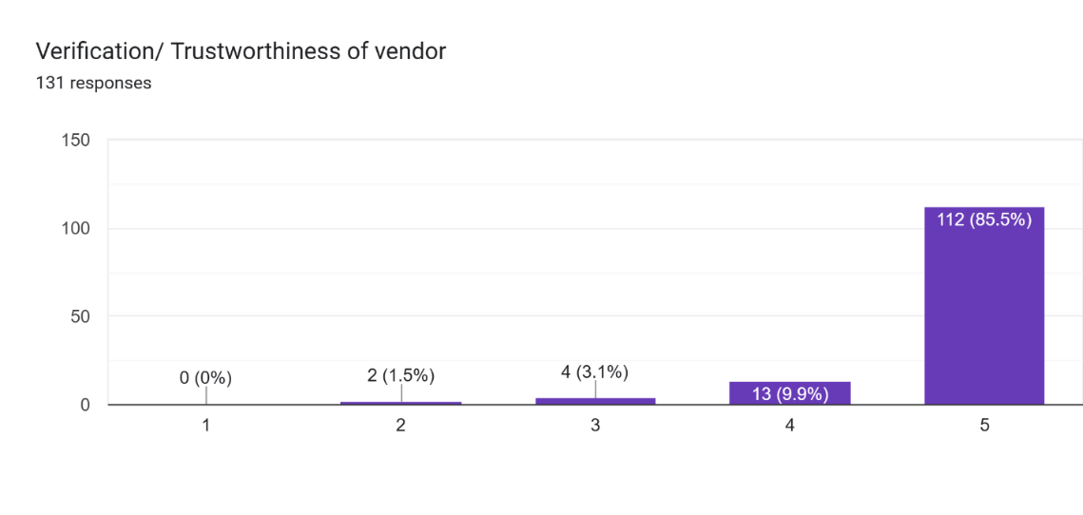
Figure 4.15: Importance of trust and verification in vendor selection (student ratings).

Challenges in Current Discovery Mechanisms
The discovery of campus services at UCC is currently very fragmented and ineffective. Word-of-mouth is predominantly the only method for discovering services used by most students, relying largely on recommendations from friends or fellow students. Physical posters and leaflets, commonly scattered around lecture theatres, hostels, or hotspots on campus, provide some visibility but are patchy and limited in coverage. Interestingly enough, there are no centralized web places dedicated to campus-specific service discovery, meaning students don't have any reliable way of browsing, comparing, and checking what is out there.
This fragmented system causes various problems. Firstly, the students waste valuable time looking for vendors, particularly during peak demand (e.g., exam periods for printing and stationery). Secondly, the reliance on social connections generates inequities whereby fresh admitted students or socially isolated members lag behind, as they lack networks to refer credible vendors. Lastly, without proof and online visibility, students cannot easily identify trustworthy service providers, thereby raising the chances of scams, varying quality, or overpayment.
The study validates the call for MANDUU geo-tagged listings, vendor authentication, and digital marketplace architecture that would aggregate discovery into a single accessible, dependable platform intended for the campus environment.
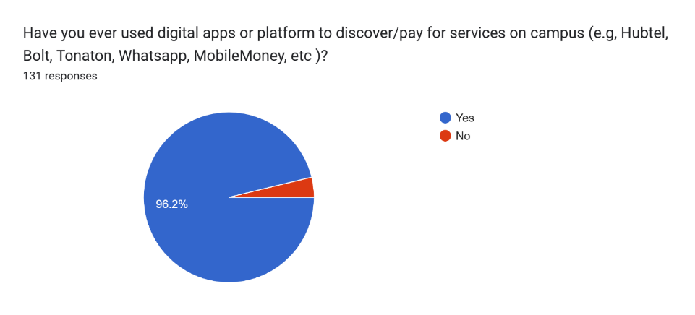
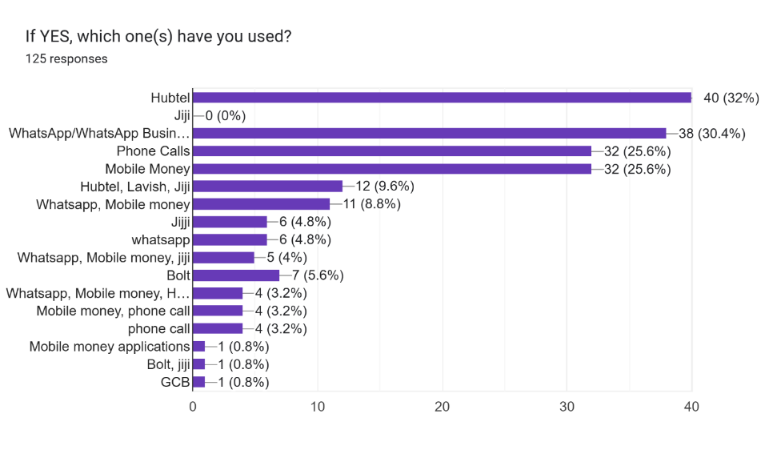
Figure 4.16: Current service discovery methods among students (pie chart and bar chart).

Reported Incidents
The student survey also uncovered a worrying trend of negative service experiences:
- Delays and congestion at print centres and repair shops.
- Delays in products deliveries.
- Overpricing or unexpected charges by some vendors.
- Cases of fraud, especially with unverified off-campus service providers.
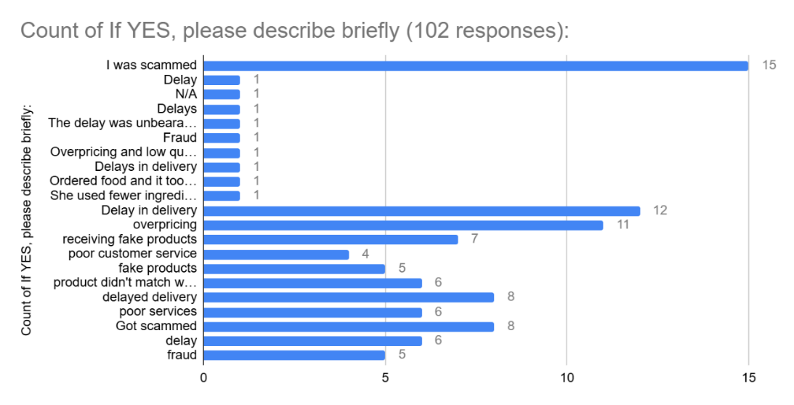
More than 60% of students admitted facing at least one challenge with campus vendors in the past academic year.
Figure 4.17: Types of challenges faced with campus vendors (percentage breakdown).

Students Priorities in Choosing Vendors
Students rated the following factors as their top priorities when selecting a vendor:
- Proximity (location-based access).
- Trust/verification of the vendor.
- Quality of service delivery.
- Price fairness and transparency.
- Ease of discovery (visibility and accessibility).
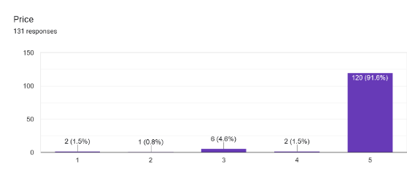
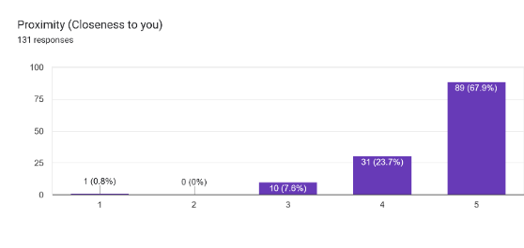
This ranking strongly validates MANDUU’s design pillars of location-based vendor discovery and verification mechanisms.
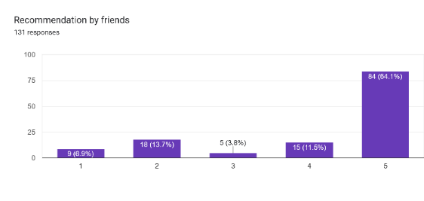
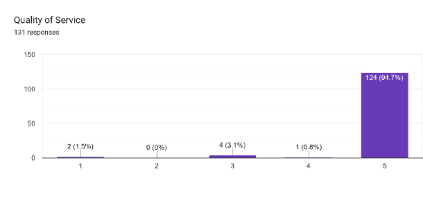
Figure 4.18: Ranked importance of vendor selection factors (student ratings on proximity and price).
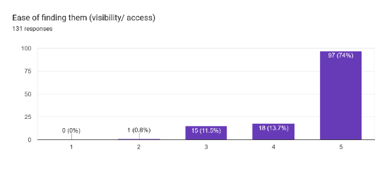
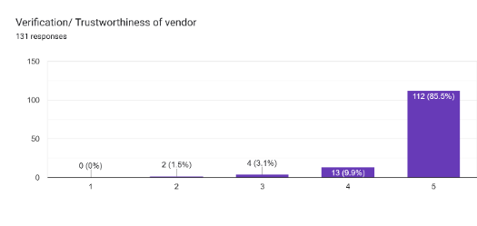
Figure 4.19: Ranked importance of vendor selection factors (student ratings on quality of services and recommendation by friends).
Figure 4.20: Ranked importance of vendor selection factors (student ratings on vendor verification and visibility).

Vendor Concern About Student Trust
Providers also had deep fears about how students perceive their services, demonstrating that trust is a two-way concern in the campus market. Less established or new providers expressed fears of not being trusted by students in the lack of a seen verification process or even institutional recognition. This lack of legitimacy also tended to limit their ability to acquire first customers, regardless of service quality. Additionally, vendors identified the rates of competition in common service categories such as printing, grooming, and food selling, where it is difficult to stand out without systematic visibility.
This dynamic emphasizes that trust is mutual: just as students require trust in vendors to avoid fraud, subpar services, or overpricing, vendors themselves also want recognition and legitimacy to legalize their enterprises and propel customer loyalty. A campus-specific, centralized platform like MANDUU addresses this dual dilemma by offering verified vendor profiles, transparent ratings/reviews, and visibility across the student population, thereby facilitating bilateral trust and allowing for more wholesome vendor–student relationships.

How MANDUU Addresses Trust and Discovery Gaps
The MANDUU platform directly integrates solutions for these gaps:
Verification mechanisms: Vendors will be required to provide basic identification or permits before being listed, while students validate accounts via institutional credentials.
Location-based service discovery: Vendors are geo-tagged within the UCC campus, enabling students to find the nearest service provider easily.
User reviews and ratings: Students can share feedback, allowing vendors to build credibility over time.
Price visibility: Transparent pricing structures reduce the risk of overcharging.
These features respond directly to the pain points expressed by both groups in the survey.
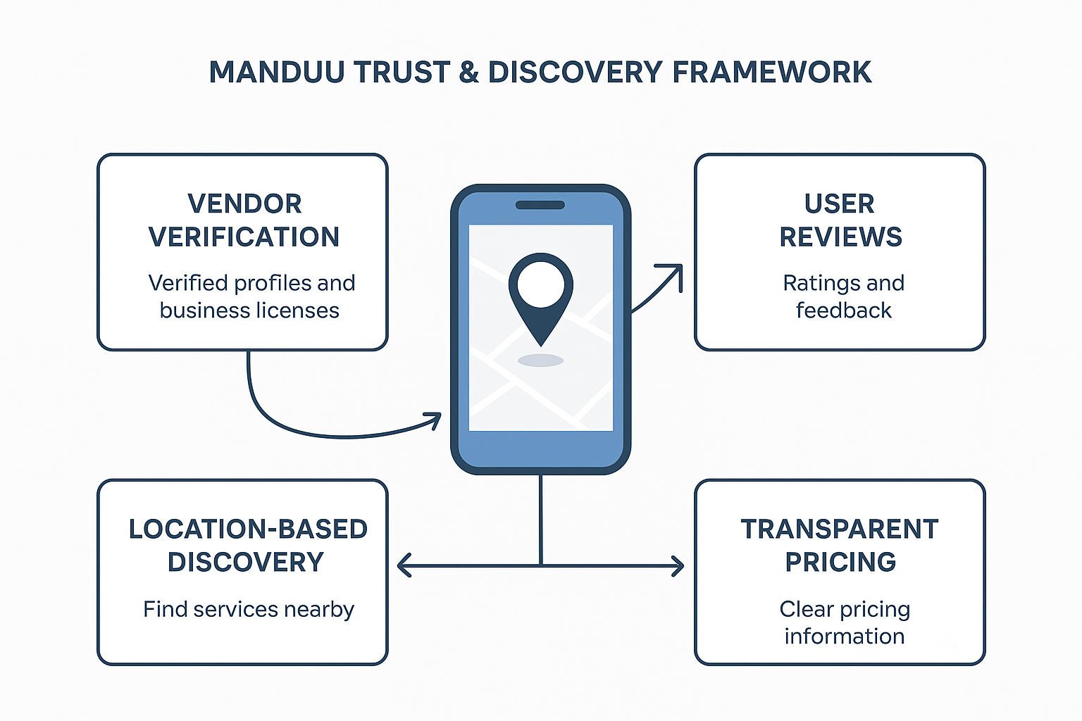
Figure 4.21: MANDUU trust and discovery framework (illustrative diagram – to be designed).

Prototype Demonstration
The MANDUU prototype was developed as a mobile-first platform to address the challenges of trust, service discovery, and transactional efficiency in the University of Cape Coast (UCC) campus environment. This section presents key interfaces and workflows from the prototype, highlighting how the system aligns with the research objectives. Screenshots are used to illustrate the main features of the application, with annotations explaining their significance.

Home and Navigation
The home screen serves as the entry point for students and vendors. It presents service categories in a structured format, ensuring that users can quickly locate vendors based on the main service categories (fashion, grocery, beauty, food, electronics) with the e-printing feature on a separate tab.
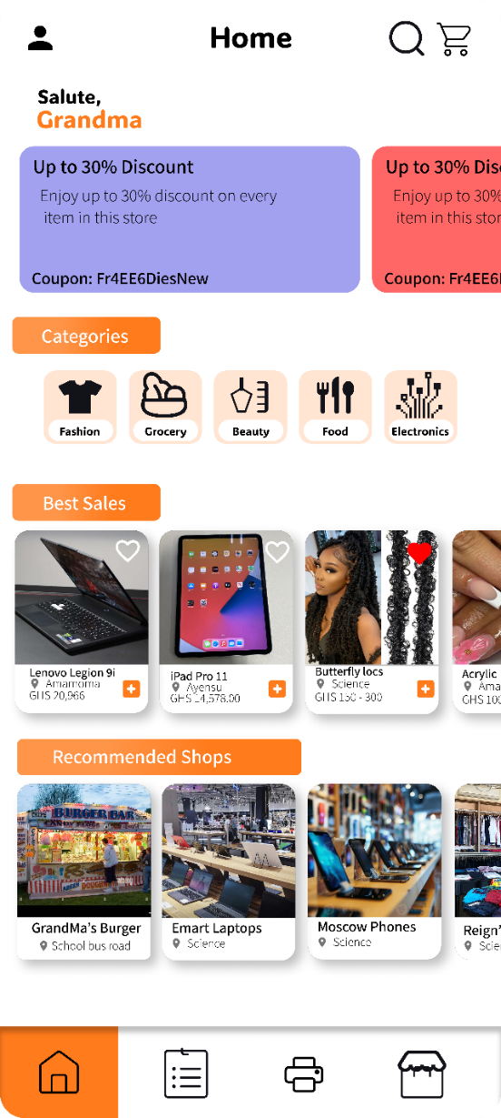
Figure 4.22: MANDUU Home Screen & Service Categories

Vendor Profiles and Verification

Each vendor has a profile displaying their services, verification status, contact options, and user ratings. Verified vendors are marked with a badge to build trust and reduce the risk of fraud.
Figure 4.23: Vendor Profile with Verification Badge

Remote Printing Workflow
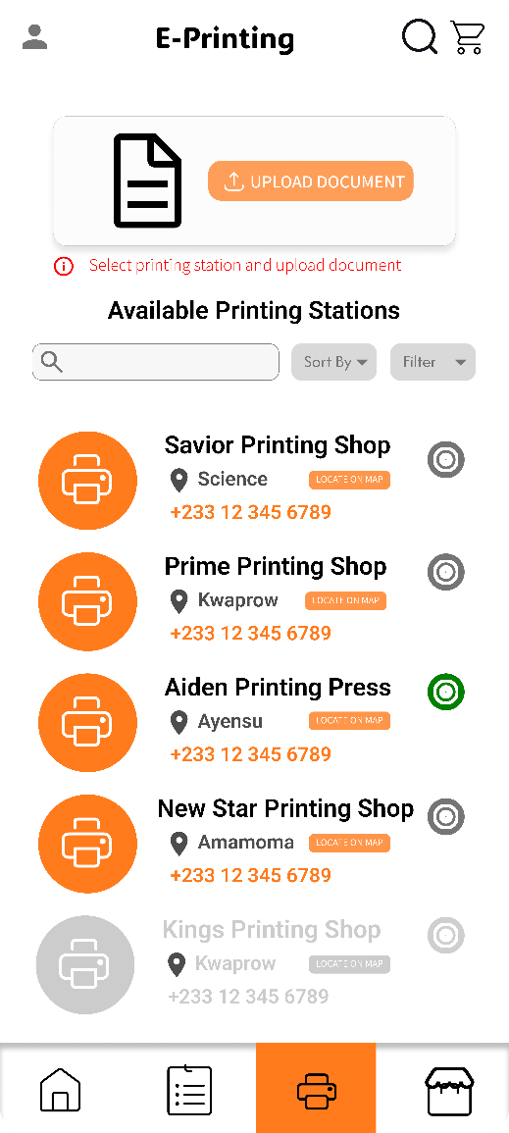
The prototype integrates an e-printing feature, allowing students to upload documents and select a preferred print vendor. This addresses long queues and peak-time congestion at print shops.
Figure 4.24: E-Printing shop selection screen

Vendor Dashboard
The vendor dashboard serves as the central interface for campus service providers to manage and monitor their business activities on the MANDUU platform. Designed with usability and efficiency in mind, the dashboard provides a consolidated space where vendors can seamlessly oversee their operations without relying on manual record-keeping or fragmented communication methods.
A key feature of the dashboard is the Order Requests module, which presents both pending and completed service requests from students. By organizing requests in a clear and structured manner, vendors are able to respond promptly, better manage their workflow, and reduce turnaround delays. This is particularly valuable in high-demand categories such as printing, grooming, and laundry, where speed and reliability strongly influence customer satisfaction.
The Sales History section enables vendors to review a comprehensive record of all past transactions. Beyond simply listing completed sales, this feature allows vendors to monitor revenue streams, identify peak service periods, and assess overall business performance over time. Such financial visibility helps vendors make informed decisions on pricing, resource allocation, and scaling opportunities.
Another important component is the Customer Feedback system, where ratings and reviews provided by students are summarized in an accessible format. This feedback mechanism not only helps vendors build trust but also provides actionable insights into areas that may require service improvement. Positive reviews contribute to vendor credibility, while constructive criticism enables continuous quality enhancement.
Additionally, the Profile Insights tool equips vendors with visibility metrics, including the number of profile visits and service saves by students. These indicators offer vendors a sense of their reach and popularity within the campus ecosystem, helping them refine their marketing strategies and evaluate the effectiveness of their service offerings.
Overall, the vendor dashboard is designed to empower campus service providers with real-time insights and oversight of their businesses. By consolidating order management, sales tracking, customer feedback, and visibility analytics into a single interface, MANDUU creates a professionalized environment for vendors, enhances decision-making, and strengthens trust between students and service provider
The vendor dashboard serves as the central interface for campus service providers to manage and monitor their business activities on the MANDUU platform. Designed with usability and efficiency in mind, the dashboard provides a consolidated space where vendors can seamlessly oversee their operations without relying on manual record-keeping or fragmented communication methods.
A key feature of the dashboard is the Order Requests module, which presents both pending and completed service requests from students. By organizing requests in a clear and structured manner, vendors are able to respond promptly, better manage their workflow, and reduce turnaround delays. This is particularly valuable in high-demand categories such as printing, grooming, and laundry, where speed and reliability strongly influence customer satisfaction.
The Sales History section enables vendors to review a comprehensive record of all past transactions. Beyond simply listing completed sales, this feature allows vendors to monitor revenue streams, identify peak service periods, and assess overall business performance over time. Such financial visibility helps vendors make informed decisions on pricing, resource allocation, and scaling opportunities.
Another important component is the Customer Feedback system, where ratings and reviews provided by students are summarized in an accessible format. This feedback mechanism not only helps vendors build trust but also provides actionable insights into areas that may require service improvement. Positive reviews contribute to vendor credibility, while constructive criticism enables continuous quality enhancement.
Additionally, the Profile Insights tool equips vendors with visibility metrics, including the number of profile visits and service saves by students. These indicators offer vendors a sense of their reach and popularity within the campus ecosystem, helping them refine their marketing strategies and evaluate the effectiveness of their service offerings.
Overall, the vendor dashboard is designed to empower campus service providers with real-time insights and oversight of their businesses. By consolidating order management, sales tracking, customer feedback, and visibility analytics into a single interface, MANDUU creates a professionalized environment for vendors, enhances decision-making, and strengthens trust between students and service providers.
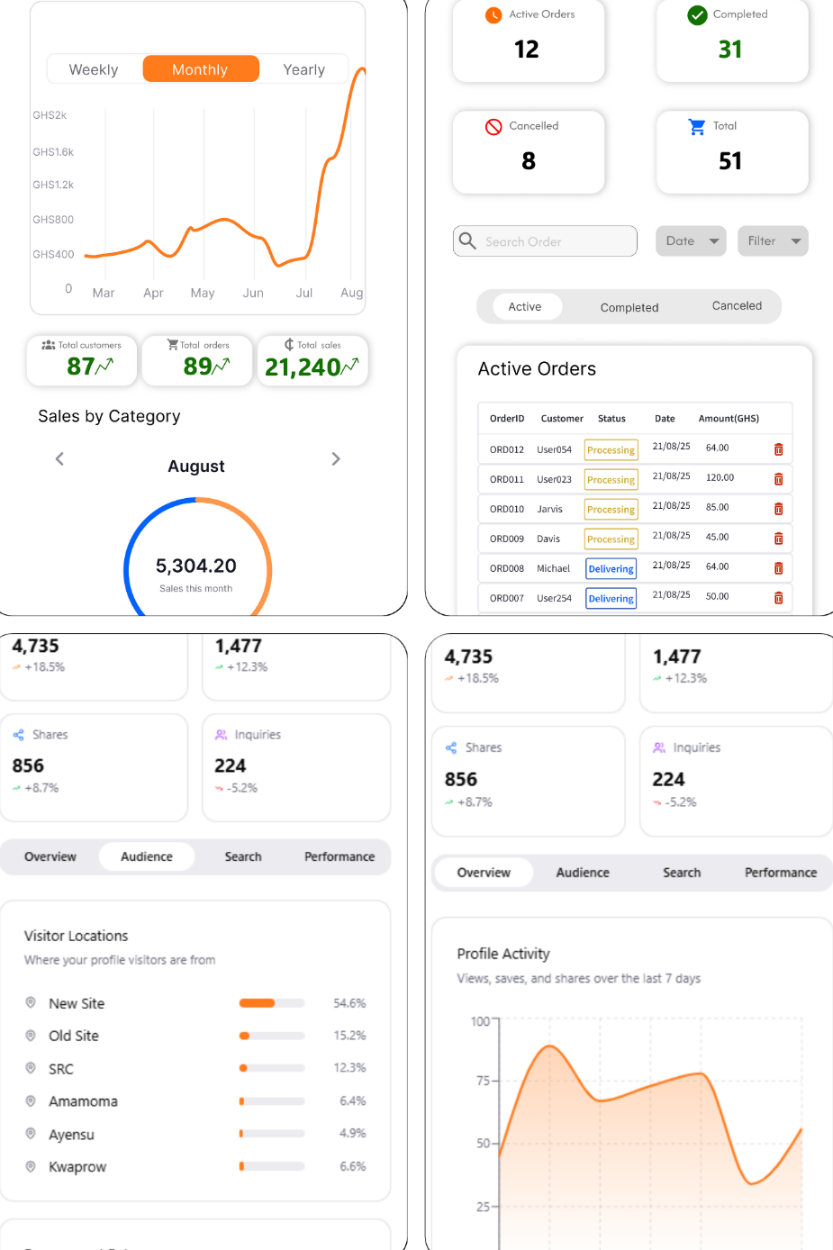
Figure 4.25: Vendor dashboard screens displaying order requests, sales history and customer views and engagement.

Purchases Tab
Students/customers can view all their purchases and order history from this tab. They can view the status of current orders, all completed orders and cancelled orders. These orders include product purchases as well as printing jobs.
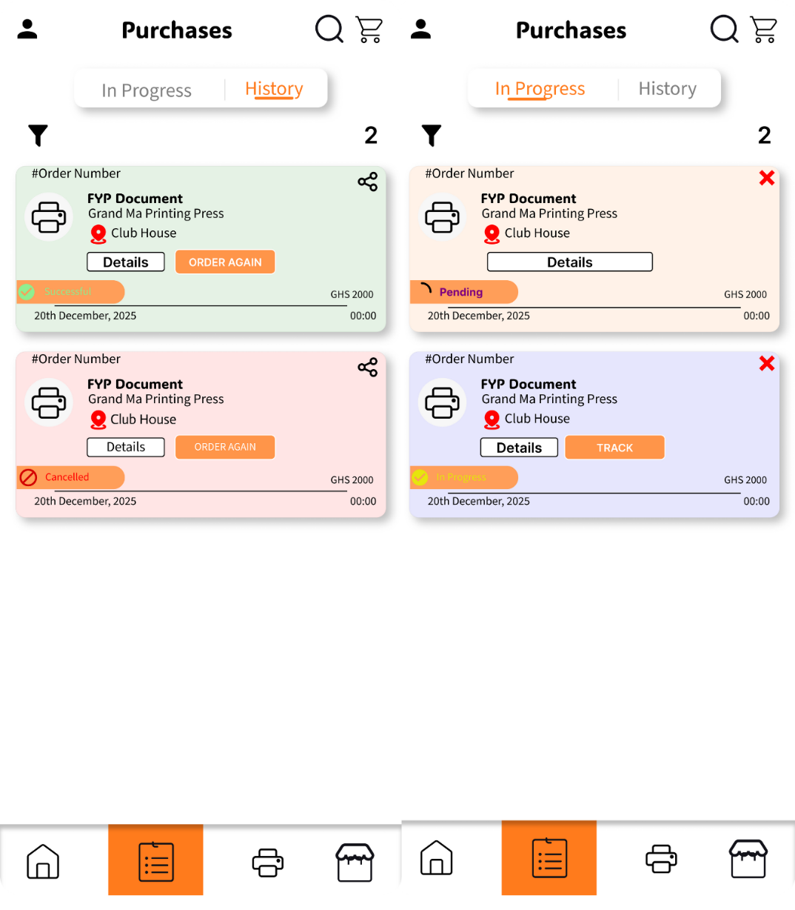
Figure 4.26: Purchases interface showing active orders and order history.

Payment Integration
A critical component of MANDUU’s functionality is its integrated payment system, which ensures that transactions between students and vendors are secure, convenient, and aligned with the financial habits prevalent within the University of Cape Coast (UCC) campus community. The payment architecture was deliberately designed to accommodate multiple channels in order to maximize inclusivity and foster trust among diverse users.
With support for all major networks in Ghana, MTN MoMo, Telecel Cash, and AirtelTigo Money, the platform ensures that both students and vendors can transact seamlessly without requiring a traditional bank account. This reflects national financial behaviour trends, where mobile money has become the dominant payment method, especially for younger populations and small-scale businesses.
In addition to Mobile Money, the platform provides for Bank Transfers, catering to users who prefer direct account-to-account payments. This option is particularly relevant for vendors with established banking relationships or students who may receive allowances and stipends through their bank accounts. By incorporating this option, MANDUU bridges the gap between digital wallets and the formal banking sector.
Furthermore, the app supports Visa and Debit Card transactions, enabling students and vendors who own bank cards to conduct payments securely. This adds an additional layer of flexibility and aligns the app with global e-commerce standards, positioning MANDUU as a modern, scalable solution that can integrate with broader digital ecosystems.
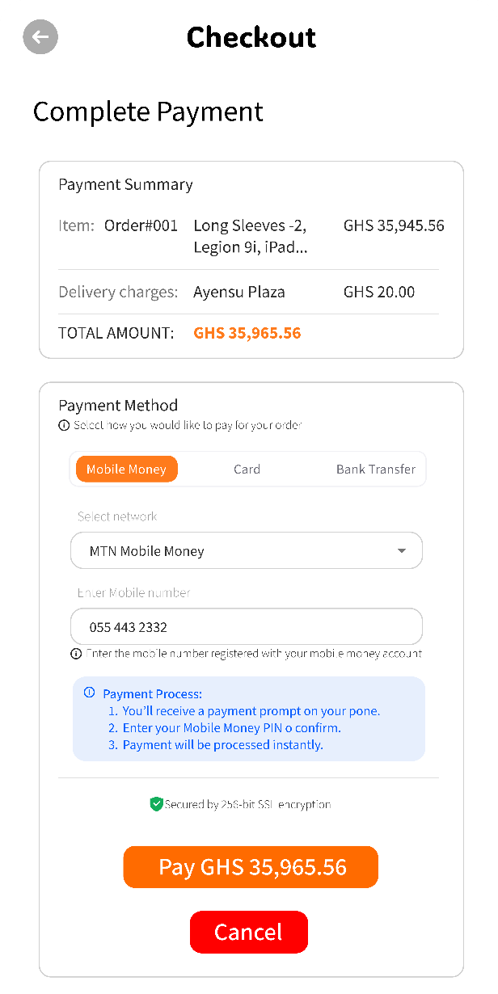
Figure 4.27: Payment Checkout Screen

Prototype Significance
The prototype demonstrates the feasibility of digitizing informal campus services into a structured marketplace. Each feature directly addresses limitations identified in Chapter 1 (Problem Statement) and validates the design science methodology adopted in Chapter 3.

System Testing and Evaluation
The evaluation of the MANDUU mobile application is designed to assess its technical performance, usability, and potential for adoption within the University of Cape Coast community. Although the platform is still under active development, the evaluation framework provides a structured way of testing the prototype and preparing for full deployment.
Testing focuses on multiple dimensions. From a functional perspective, modules such as user registration, login, vendor onboarding, service categorization, and the remote e-printing workflow have been checked against their design specifications. These checks confirm that navigation works smoothly, student accounts can be created and verified, vendors can upload services under appropriate categories, and documents can be submitted digitally for printing. Each of these steps demonstrates the prototype’s ability to replicate campus service transactions in a secure and structured manner.
Equally important is usability testing, which is oriented toward the end-user experience. Students and vendors highlighted through surveys the need for simplicity, clarity of service categories, and ease of access. The current prototype reflects these expectations by offering a clean dashboard, location-tagged service listings, and vendor profiles with verification badges. Planned usability testing sessions will therefore examine how quickly students can discover services, how easily vendors can manage their listings, and whether the e-printing process reduces queues at print centres.
Trust and safety are central evaluation criteria. The survey results revealed that over 70% of students considered vendor verification and service quality as highly important. MANDUU addresses these concerns by incorporating vendor ID verification, student account validation through institutional email, and user-generated reviews. The evaluation framework will therefore track how these trust mechanisms influence adoption and reduce incidents of fraud or poor service quality.
From a performance perspective, future testing will measure response times for core operations. For instance, uploading an e-printing document should take less than five seconds on average, while vendor listings should load instantly within a geofenced campus radius. Performance will also be assessed during peak usage, such as examination periods when demand for printing is high. Scalability will be tested by simulating hundreds of concurrent student requests to ensure system stability.
Finally, adoption intent forms the last pillar of evaluation. Survey data show that most students are either “likely” or “very likely” to use the app, while vendors expressed strong interest due to the promise of higher visibility and easier payments. These preliminary findings will act as a baseline against which real adoption levels can be compared once the system is launched.
Together, these evaluation dimensions; functionality, usability, trust and safety, performance, and adoption intent, form a comprehensive framework for assessing the MANDUU app. They ensure that the system is not only technically sound but also relevant and reliable for its users. Testing and evaluation will be iterative, beginning with the current prototype and extending into live pilot deployments, allowing continuous improvement and alignment with student and vendor needs.

CHAPTER FIVE: DISCUSSION, CONCLUSION AND RECOMMENDATIONS

Introduction
This chapter synthesizes the findings of the study, interprets their implications, and aligns them with the research objectives and existing literature reviewed in Chapter Two. While Chapter Four presented the results of the student and vendor surveys, as well as insights from the prototype demonstration, this chapter moves a step further to discuss what these results mean in the context of campus commerce at the University of Cape Coast (UCC).
The discussion is structured around the research objectives, drawing clear connections between the problems identified, the solutions proposed through the MANDUU platform, and the responses obtained from stakeholders. Particular emphasis is placed on the issues of trust, service discovery, convenience, and inclusivity, which emerged as central themes throughout the study. By comparing these findings with existing studies on mobile commerce, platform adoption, and informal economies in university settings, the analysis highlights both the consistencies and unique contributions of this research.
The chapter also presents the conclusion, summarizing the study’s main insights and reflecting on its broader academic and practical significance. Finally, it provides recommendations, directed at three levels:
- For students and vendors – to maximize adoption and effective use of MANDUU.
- For the University of Cape Coast – to support integration and sustainability of the platform.
- For future researchers and developers – to improve upon the prototype and extend the study to other campuses.
In doing so, this chapter closes the loop of the research process, ensuring that the results are not only presented but critically analysed and contextualized for practical and scholarly value.

Discussion of Findings
The findings of this study provide important insights into the challenges and opportunities associated with campus service delivery at the University of Cape Coast, as well as the potential of the MANDUU platform to address these gaps. The survey confirmed that student demand for services is wide-ranging, with printing, stationery, grooming, laundry, and device repairs emerging as the most dominant categories. These services are accessed frequently, often on a daily or weekly basis, which highlights the centrality of such activities in student life. However, access remains constrained by the fragmented nature of service discovery. Students typically rely on word-of-mouth, posters, and peer recommendations to locate vendors, a process that is inefficient and particularly challenging for first-year or isolated students who may lack strong social connections. This fragmented discovery system mirrors observations in earlier studies of informal commerce in Ghanaian universities, where lack of structured marketing channels was shown to increase time and effort costs for students seeking essential services. MANDUU’s geo-tagged listings and campus-specific service mapping directly respond to this inefficiency by offering a structured, location-based solution that reduces reliance on informal networks and ensures inclusivity in service discovery.
Another significant finding centres on the issue of trust. Over 80% of student respondents rated vendor trust and verification as very important when choosing service providers, while vendors themselves emphasized the difficulty of gaining legitimacy and sustaining customer confidence, especially when new to the campus ecosystem. This creates a bi-directional trust gap: students fear fraud, poor quality, or overpricing, while vendors fear invisibility and lack of credibility. Existing research highlights that digital platforms can address these gaps through embedded verification and reputation mechanisms. MANDUU integrates such measures by requiring vendor verification through permits or IDs, student account validation via institutional credentials, and reputation-building through ratings and reviews. Additionally, transparent pricing mechanisms are introduced to reduce hidden costs and disputes. In doing so, the app directly addresses the structural weaknesses of the current informal system, offering trust as a core value proposition for both students and vendors.
The survey also revealed strong entrepreneurial ambitions among students, with several respondents already engaged in small-scale services or planning to start one. Yet these student entrepreneurs reported persistent challenges, including low visibility, limited marketing expertise, and difficulty competing with more established vendors. This aligns with existing studies that describe student-run enterprises in Ghana as vibrant but largely constrained by informality and lack of scale. By serving as a launchpad for these ventures, MANDUU provides student vendors with visibility beyond their immediate peer groups. Verified listings, searchable categories, and reviews ensure that even new entrants can build credibility, reducing the reliance on personal networks alone. This not only supports the entrepreneurial ecosystem within UCC but also contributes to the broader national agenda of fostering youth entrepreneurship and reducing graduate unemployment.
Payments and transaction security were also critical issues highlighted in the findings. While mobile money and cash remain the dominant modes of payment on campus, both students and vendors expressed concerns about the lack of transparency and security in cash transactions. Research on mobile commerce adoption in Ghana identifies transaction reliability as a critical factor influencing platform adoption. MANDUU responds by supporting multiple secure payment options, including mobile money across all networks, bank transfers, and Visa or debit card payments. By providing flexibility while ensuring traceability, the platform enhances trust in financial transactions and reduces the risks associated with handling cash.
At the institutional level, inefficiencies such as long queues at print shops and congestion during peak academic periods were identified as major pain points. These challenges not only frustrate students but also place strain on vendors and campus facilities. MANDUU’s introduction of e-printing and pre-scheduled service requests directly addresses these inefficiencies, smoothing demand distribution and minimizing waiting times. In addition, the app can generate valuable analytics on peak demand, most popular services, and user preferences, which could be leveraged by UCC for better planning and policy decisions. Economically, the platform has the potential to formalize the largely informal campus service sector, strengthen vendor revenues, and create a sustainable digital marketplace ecosystem.
The vendor perspective adds further depth to these findings. While vendors expressed high interest in joining a platform like MANDUU, they also highlighted critical support needs such as training on app usage, assistance with creating professional profiles, and marketing support. This suggests that the success of MANDUU depends not only on technological deployment but also on vendor onboarding and capacity building. Concerns such as low student adoption, affordability of listing fees, and privacy issues also need to be addressed proactively to build trust and confidence among vendors.
Overall, the findings show that the MANDUU platform directly integrates solutions to the most pressing challenges identified by both students and vendors. Service discovery inefficiencies are resolved through location-based listings, trust is reinforced through verification and reviews, entrepreneurship is promoted through visibility and legitimacy, payments are secured through multiple channels, and institutional inefficiencies are alleviated through digital coordination of services. Together, these outcomes demonstrate that MANDUU has the potential to transform campus commerce into a transparent, efficient, and inclusive ecosystem that benefits students, vendors, and the university alike.

Conclusion
This study set out to explore the challenges of campus commerce at the University of Cape Coast (UCC) and propose a digital solution, MANDUU, to address these gaps. The research findings have consistently demonstrated that both students and vendors experience significant inefficiencies in the current informal system. Students struggle with locating trusted vendors, navigating inconsistent service quality, and enduring long queues, particularly at printing centres and other high-demand service points. Vendors, on the other hand, face challenges of low visibility, limited marketing capacity, and difficulty gaining credibility within the student market. These findings resonate with broader literature on informal service economies in developing countries, where discovery, trust, and transaction inefficiencies often undermine market efficiency.
The MANDUU platform was designed as a targeted intervention to resolve these issues by leveraging geo-tagged listings, verification systems, secure payment options, and user feedback mechanisms. By providing students with a centralized platform for accessing campus services, MANDUU enhances convenience, transparency, and trust. At the same time, it offers vendors improved visibility, credibility, and business insights, thereby supporting their entrepreneurial growth. The platform’s scalability also positions it as a potential model for replication across other Ghanaian campuses, extending its impact beyond UCC.
Importantly, the study demonstrates that digital solutions tailored to specific institutional and cultural contexts can generate significant social and economic value. By aligning with student needs, vendor expectations, and institutional priorities, MANDUU addresses a unique gap in campus commerce while contributing to broader goals of digital transformation and youth entrepreneurship. The results reaffirm the importance of trust-building, inclusivity, and usability in platform design, highlighting that technology alone is insufficient without strategies for adoption, training, and capacity building.
In conclusion, MANDUU is more than a digital marketplace: it represents a framework for reimagining campus services in a way that prioritizes convenience, accountability, and shared growth. While the prototype remains under development, the positive reception from both students and vendors suggests a strong foundation for future implementation and scaling. The study thus contributes both practically, by offering a viable campus commerce solution, and academically, by enriching the body of knowledge on mobile platforms in developing-country university contexts.

Recommendations and Suggestions for Future Research
The MANDUU mobile application testing is aimed at assessing its technical functionality, usability, and adoptability potential among the Cape Coast University populace. Although the site is ongoingly being developed, the test framework accounts for a sequential method of piloting the prototype and culminating in full deployment.
Testing aims at targeting a number of various dimensions. From a functionality perspective, onboarding modules such as vendors, registration of users, login, categorization of services, and remote e-printing have been tested against specification. Navigation has been checked to be smooth, student accounts can be created and authenticated, vendors can load services into correct categories, and documents can be loaded electronically to print. All of these demonstrate how the prototype can replicate campus service transactions securely and in an orderly manner.
Secondary, usability testing is concerned with the end-user experience. Students and vendors identified through surveys simplicity, clarity of service categories, and ease of access. The current prototype fulfills these through the offering of a clean dashboard, location-tagged services, and vendor profiles with verification badges. Scheduled usability testing sessions will thereby explore how efficiently students can find services, how easily vendors can manage their listings, and if the e-printing process reduces lines at print centres.
Trust and safety are key evaluation metrics. The survey findings showed that over 70% of the students considered vendor verification and service quality to be very important. MANDUU dispels such apprehensions through provision of vendor ID verification, student account confirmation through institutional email, and peer reviews. The framework for evaluation will therefore check how much such trust measures impact take-up and reduce instances of fraud or poor service quality.
From a performance perspective, upcoming testing will record response time for key operations. For instance, uploading an e-printing document takes less than five seconds on average, and vendor lists should load up instantly within a geofenced campus boundary. Performance will also be tested under heavy usage, such as exam times when printing demand is high. Scalability will be confirmed by simulating hundreds of simultaneous requests by students to put system stability to test.
Lastly, adoption intention is the final pillar of measurement. Data from the surveys indicate that a majority of the students are "likely" or "very likely" to use the app, and vendors too were keenly interested because of the prospect of increased visibility as well as convenient payments. These initial results will serve as a basis of comparison against which actual adoption levels can be measured after the system is implemented.
All these assessment measures; usability, functionality, trust and safety, performance, and intent to adopt, form a comprehensive assessment framework for establishing the MANDUU application. They ensure that the system is not only technically sound but also suitable and trustworthy to its users. Testing and evaluation will be an iterative cycle, beginning with the current prototype and progressing into live pilot deployments, with continuous development and alignment of student and vendor needs.

REFERENCES
Adam, A. M. (2020). Sample size determination in survey research. Journal of Scientific Research and Reports, 26(5), 90–97. https://doi.org/10.9734/jsrr/2020/v26i530263
Addo, A. (2021). Informal campus services and student access challenges in Ghanaian universities. Journal of African Higher Education, 7(2), 89–105.
Afif, M. H. (2023). Assessing students’ perceptions of mobile applications usability using System Usability Scale. Journal of Computer Science, 19(1), 11–19. https://doi.org/10.3844/jcssp.2023.11.19
Akanferi, A. A., Asampana, I., Matey, A. H., & Tanye, H. A. (2022). Adoption of mobile commerce and mobile payments in Ghana: An examination of factors influencing public servants. Interdisciplinary Journal of Information, Knowledge, and Management, 17, 287–313. https://doi.org/10.28945/4981
Asare, B., & Nkrumah, J. (2019). Youth entrepreneurship on campus: Barriers and prospects in Ghana. Ghana Journal of Education and Development, 12(1), 45–61.
Boateng, R., & Essuman, D. (2020). Navigating informal service economies: Student access and visibility. International Journal of University Commerce, 3(4), 27–40.
Brooke, J. (1996). SUS: A quick and dirty usability scale. In P. W. Jordan, B. Thomas, B. A. Weerdmeester, & A. L. McClelland (Eds.), Usability Evaluation in Industry (pp. 189–194). London: Taylor & Francis.
Chin, A. G., Harris, M. A., & Brookshire, R. (2018). A bidirectional perspective of trust and risk in determining factors that influence mobile app installation. International Journal of Information Management, 39, 49–59. https://doi.org/10.1016/j.ijinfomgt.2017.11.010
Davis, F. D. (1989). Perceived usefulness, perceived ease of use, and user acceptance of information technology. MIS Quarterly, 13(3), 319–340.
Dzogbenuku, R. K., Boateng, E., & Essandoh, P. K. (2021). Drivers of mobile commerce adoption in Ghana: The role of trust and digital infrastructure. Technology in Society, 67, 101–110.
G Consulting International Services. (n.d.). How to select the sample and calculate sample size for survey [Web page].
Gefen, D. (2000). E-commerce: The role of familiarity and trust. Omega, 28(6), 725–737. https://doi.org/10.1016/S0305-0483(00)00021-9
GSMA. (2023). State of the industry report on mobile money 2023. GSMA. https://www.gsma.com/solutions-and-impact/connectivity-for-good/mobile-for-development/gsma_resources/state-of-the-industry-report-on-mobile-money-2023-2/
Hevner, A. R., March, S. T., Park, J., & Ram, S. (2004). Design Science in Information Systems Research. MIS Quarterly, 28(1), 75–105.
Hornuf, L., Safari, K., & Voshaar, J. (2024). Mobile fintech adoption in Sub-Saharan Africa: A systematic literature review and meta-analysis. Research in International Business and Finance, 73, 102529. https://doi.org/10.1016/j.ribaf.2024.102529
Hubtel. (2024, March 6). Hubtel’s success story becomes the first from Ghana to be highlighted by Amazon Web Services [Blog post]. Hubtel News. https://blog.hubtel.com/hubtels-success-story-highlighted-by-aws
Influencing continued usage of mobile money service transactions in Ghana. Journal of Innovation and Entrepreneurship, 12, Article 34. https://doi.org/10.1186/s13731-023-00301-3
International Organization for Standardization. (2018). ISO 9241–210:2018 Ergonomics of human-system interaction — Part 210: Human-centred design for interactive systems. ISO.
Kemp, S. (2023, February). Digital 2023: Ghana. DataReportal. https://datareportal.com/reports/digital-2023-ghana
Kwetey, G. A. (2020). Digital marketplace innovation and local economies in West Africa. Development in Practice, 30(7), 795–805. https://doi.org/10.1080/09614524.2020.1805582
Lee, E., Yeh, H. J., Yang, H.-S., Moon, S. B., & Choi, O. (2015). A secure NFC-based mobile printing service using recognition robot. International Journal of Distributed Sensor Networks, 11(9), Article 564506. https://doi.org/10.1155/2015/564506
Lumor, T., Pulkkinen, M., & Hirvonen, A. (2020). The actual adoption and use of mobile apps: The case of a higher education context. AMCIS 2020 Proceedings. https://aisel.aisnet.org/amcis2020/adoption_diffusion_IT/adoption_diffusion_IT/23
McKnight, D. H., Choudhury, V., & Kacmar, C. (2002). The impact of initial consumer trust on intentions to transact with a web site: A trust-building model. Information Systems Research, 13(3), 334–359.
Mensah, J., & Adams, S. (2022). Trust badges and platform adoption: Evidence from Ghanaian e-marketplaces. African Journal of Information Systems, 14(3), 135–152.
Nielsen, J. (1994, February). Enhancing the explanatory power of usability heuristics. In CHI’94: Proceedings of the SIGCHI Conference on Human Factors in Computing Systems (pp. 152–158). https://doi.org/10.1145/191666.191729
Osabutey, E. L. C., & Jackson, T. (2024). Mobile money and financial inclusion in Africa: Emerging themes, challenges and policy implications. Technological Forecasting and Social Change, 202, Article 123339. https://doi.org/10.1016/j.techfore.2024.123339
Peffers, K., Tuunanen, T., Gengler, C. E., Rossi, M., Hui, W., Virtanen, V., & Bragge, J. (2020). Design Science Research Process: A Model for Producing and Presenting Information Systems Research.
Petcovici, A., & Stroulia, E. (2016). Location-based services on a smart campus: A system and a study. In 2016 IEEE 3rd World Forum on Internet of Things (WF-IoT) (pp. 94–99). IEEE. https://doi.org/10.1109/WF-IoT.2016.7845406
Poudel, O., Acharya, P., & Simkhada, D. (2023). Customers’ trust in e-payment: The influence of security and privacy. BMC Journal of Scientific Research, 6(1), 97–112. https://doi.org/10.3126/bmcjsr.v6i1.60958
Robiin, B., & Pujiyono, W. (2020). Campus stalls: A marketplace specifically for students’ college needs. International Journal of Computer Applications, 176(31), 22–27.
World Bank. (2020). Digital entrepreneurship for youth: Opportunities and challenges [Report]. World Bank Publications.
Wroblewski, L. (2010). Mobile First [PDF]. https://www.lukew.com/resources/mobile-first
Yamane, T. (1967). Statistics: An Introductory Analysis (2nd ed.). New York, NY: Harper & Row.
Yeboah, E., Boateng, R., Owusu, A., Afful-Dadzie, E., & Ofori-Amanfo, J. (2020). Assessing the role of trust in merchant adoption of mobile payments in Ghana. In M. Hattingh et al. (Eds.), Responsible Design, Implementation and Use of Information and Communication Technology (pp. 204–215). Springer. https://doi.org/10.1007/978-3-030-44999-5_17

